Health & Safety
task Risk Analysis (TRA) Form

Ra No.ERMS Ref: | Date: | Version No.: | Review Date: | Authorised by:

STEP 1 – ENTER INFORMATION ABOUT THE ACTIVITY/TASK, ITS LOCATION AND THE PEOPLE COMPLETING THE RISK ASSESSMENT

Location name: | Building No.: | Room No.: | Assessed by: | HSR/Employee representative:
Description of activity/task:

Workplace conditions (Describe layout and physical conditions - including access and egress)

List systems of work for the activity/task:
● Training ● Inspections
● SOPs ● Existing controls
● Emergency situations
Is there past experience with the activity/task that may assist in the assessment?
● Existing controls ● SOPs ● Standards
● Industry standards ● Incidents & near-hits ● Legislation & Codes
● Training ● Incident Investigation ● Guidance material

Step 2: RISK RATING – RISK MATRIX AND DEFINITIONS

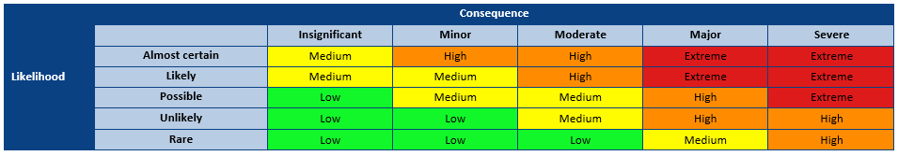
Likelihood |  | Consequence
Almost certain – will occur in most circumstances when the activity is undertaken (greater than 90% chance of occurring) |  | Insignificant –First aid treatment, minor injury, no time off work
Likely - will probably occur in most circumstances when the activity is undertaken (51 to 90% chance of occurring) |  | Minor – Single occurrence of medical treatment, minor injury, no time off work
Possible – might occur when the activity is undertaken (21 to 50% chance of occurring) |  | Moderate – Multiple medical treatments, non-permanent injury, less than 10 days off work
Unlikely – could happen at some time when the activity is undertaken (1 to 20% chance of occurring) |  | Major – Extensive injuries requiring medical treatment (e.g., surgery), serious or permanent injury/illness, greater than 10 days off work
Rare – may happen only in exceptional circumstances when the activity is undertaken (less than 1% chance of occurring) |  | Severe – Severe injury/illness requiring life support, actual or potential fatality, greater than 250 days off work

Risk Rating Priority for Action
 | Risk acceptance guide | Action | Recommended action time frame
Extreme | Not acceptable | Cease or isolate source of risk  Implement further risk controls  Monitor, review and document controls | Immediate  Up to 1 month  Ongoing
High | Generally (in most circumstances) not acceptable | Implement risk controls if reasonably practicable  Monitor, review and document controls | 1 to 3 months  Ongoing
Medium | Generally (in most circumstances) acceptable | Implement risk controls if reasonably practicable  Monitor, review and document controls | 3 to 6 months  Ongoing
Low | Acceptable | Monitor and review | Ongoing

STEP 3 – Identify hazards and associated risk ratings and controls
For each step in the task:  - Break down the task into manageable steps. List the steps in the order that they occur.  - Identify the hazard(s) associated with each step.  - Determine and record an inherent risk score using the risk matrixr.  - Provide a control description for each current or proposed risk control.  - Specify the risk control type, for each current or proposed risk control.  - Where proposed risk control(s) have been identified complete an Health & Safety: Action plan;  - Determine and record the residual risk score using the risk matrix. | Hierarchy of Control (Control Type)  El – Elimination  S – Substitution  En – Engineering Is – Isolation G – Guarding  Sh – Shielding  A – Administrative T – Training In – Inspection  M – Monitoring H – Health Monitoring  P – PPE

Category – Steps in the Task | Hazards | Inherent  Risk Score | Control Description  (Current and Proposed) | Control Type | Residual Risk Score

STEP 4 – ImpleMEntation and consultation process
Determine the person responsible for reviewing and implementing the risk assessment including the identified controls. Ensure a Health & Safety: Action plan has been completed, reviewed and signed off where proposed controls have been identified.
Obtain the authorisation of the management representative.
Ensure the HSR (if applicable) has been consulted. Ensure the employees undertaking the activity have been consulted.
Record below the names of the persons consulted.
Management representative |  |  | HSR/Employee representative
Employee(s) |  |  | Employee(s)
Employee(s) |  |  | Employee(s)
Person Responsible for implementation or escalation

Extra writing room - use this page to enter extended comments or descriptions
For use in conjunction with the Health & Safety: Risk management requirements.
For further information, refer to https://safety.unimelb.edu.au/safety-topics/management-systems/implement or contact your Health and Safety Business Partner.

