The University of Melbourne

Date: Month: August 2023
Review Date: August 2028
Version No. 1.0
Authorised by: Manager, Health & Safety Integration
Chemical Spill Response
Quick Guide

1. | 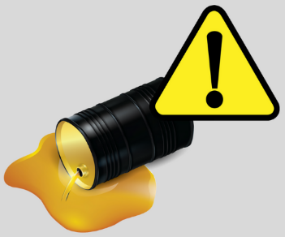  Assess the risk | Always seek assistance. Do not attempt to clean up a spill by yourself.  - If safe to do so, rescue any person in immediate danger.  - Use an emergency safety shower/eyewash if the substance is spilt on person.  - Identify the spilt chemical (substance/class).  - Call 000 for major spills or if chemical is unknown.  - Seek assistance from the Chief Warden and/or your supervisor for spill response and required PPE. If in doubt, consult the SDS.  - Isolate the area with bollards and/or witches hats.  - Seek assistance with traffic management. Call security on 8344 6666 if needed.
2. | 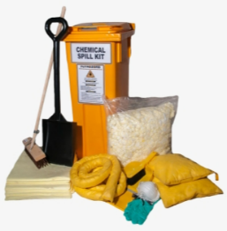  Spill kit and PPE | - Locate the spill kit (as recommended by the Chief Warden, supervisor or SDS).  - Tie back long hair and secure jewelry.  - Put on PPE (as recommended by the Chief Warden, supervisor or SDS).  - Ventilate the area to reduce the risk of exposure to harmful vapours.
3. | Contain the spill  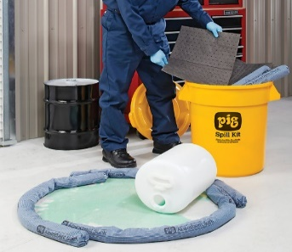 | - Where possible, stop the spill at the origin e.g. turn off valves, turn the chemical container upright or plug a leak, if safe to do so.  - Bund, dam or divert the spill to minimise clean-up.  - Contain the spill at the furthest point from the source using absorbent pads, chemical socks or surrounding the spill in vermiculate.  - Once the spill is contained, neutralise the spill if required (e.g. use bicarbonate for acid spills).
4. | 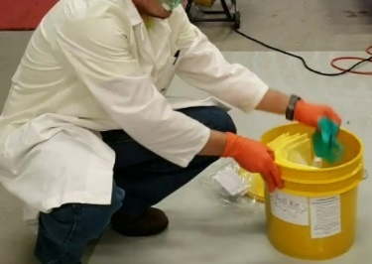  Clean up the spill | - Generously cover the spill in absorbent products. Use a broom or brush to ensure the spill is fully covered.  - Use a scoop or dustpan to put all contaminated products into waste bucket or heavy plastic waste bag (include PPE and broken container/glass).  - Label plastic bucket/waste bag with marker pen. Make sure to include chemical / substance name, DG class and details of person disposing.  - Take the labeled bucket/waste bag to the nearest waste collection point.
5. | Report and restock | - Report the incident in the university’s online incident reporting system (ERMS).  - Restock and replace the used spill kit(s).  - Arrange collection of the plastic bucket/waste bag by submitting a Service Now ticket for a Hazardous Waste Collection Request.

