
HEALTH AND SAFETY
Hazardous Waste Labels

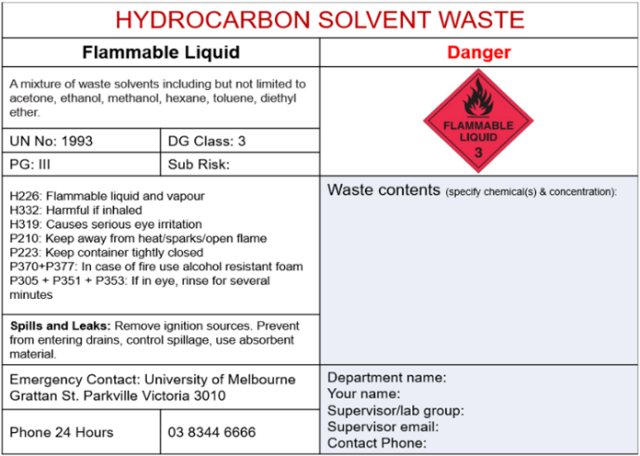
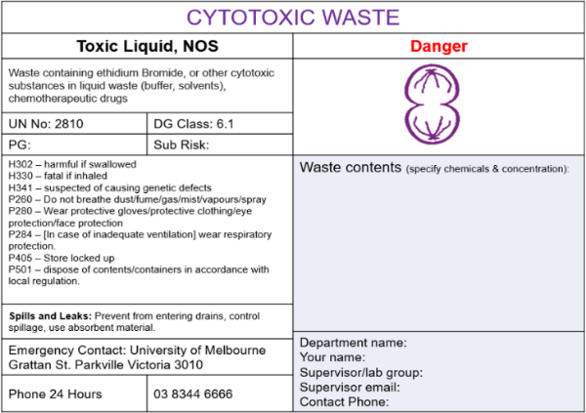
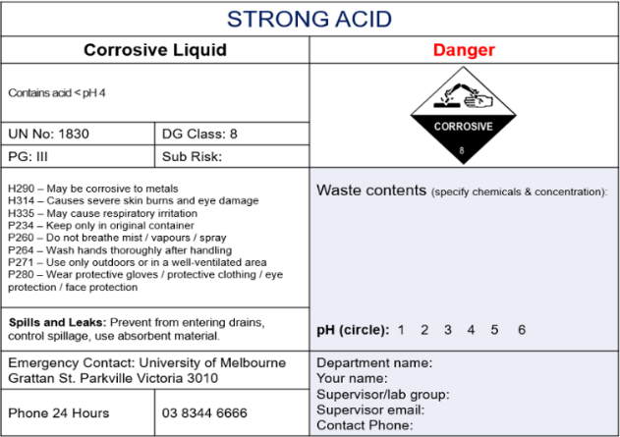

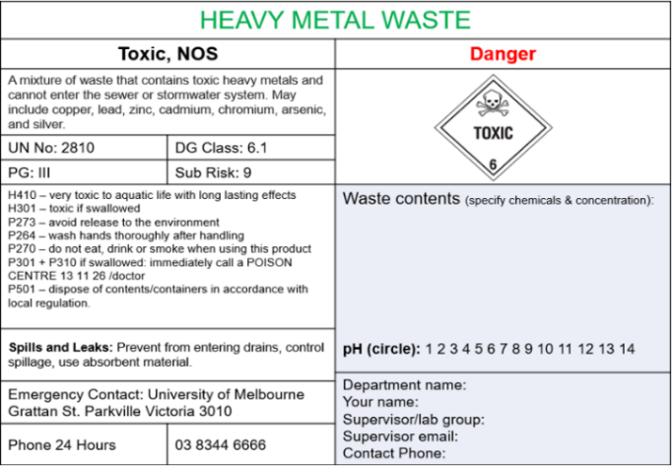
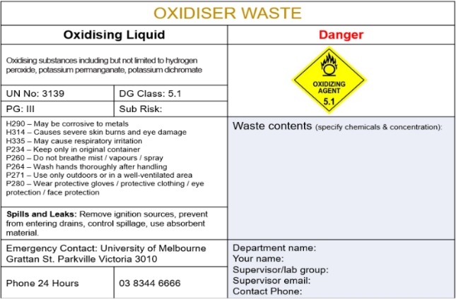

HAZARDOUS WASTE LABELS

Important notes on how to use these labels

Each laboratory group is responsible to ensure their waste is safe for storage, handling and transport.
The chemical waste contractor has the right to refuse to take non-compliance waste, e.g. bulged carboys, ripped label, or unclear description of waste.

Steps:
- Use these labels in conjunction with the ‘Hazardous Waste Guidance Sheet’ available on the Hazardous Waste webpage à See the guidance section
- Choose the correct label for the waste to be disposed:
- Labels must be printed in colour on self-adhesive stickers. It is not acceptable to use sticky tapes as the labels can peel off the carboy.
- Labels are already sized to fit:
  - Avery labels – code L7168
  - COS labels – code LABL1006
- The correct information must be provided (highlighted in blue):
  - Waste Content – specify the chemicals and their estimate concentration,
  - pH (where applicable),
  - Details of Department, Name, Supervisor and Contact Number

