
SAFETY BULLETIN
Safer Cutting Tool Alternatives
September 2026

Introduction
Cutting tools such as utility knives, scalpels, box cutters and craft knives are used across a range of university activities, including receiving and unpacking deliveries, property and maintenance work, stores operations, exhibition and event preparation, research and teaching activities. This bulletin highlights safer cutting tool alternatives and practical measures to reduce the likelihood and severity of injuries caused by cutting tools across university workplaces.

Risk
Cuts and lacerations are the most common injuries associated with the use of utility knives, box cutters and other handheld cutting tools. Injuries can occur when:
- Inappropriate tools are selected for the task.
- Blades are damaged, worn or defective.
- Folding or locking mechanisms fail unexpectedly.
- Excessive force is applied during cutting tasks.
- Hands or fingers are positioned within the cutting path.

Safer Cutting Options

No-Blade / Ceramic Micro-Blade Cutters | Concealed-Blade Safety Cutters | Auto-Retracting Safety Knives
For light cutting tasks such as splitting tape, paper, or packaging.  Example: Secuplus Ripper and Slice Safety Cutter | These cutters are designed to cut through layers of paper, packaging or cardboard. Example: Pacific Handy Cutter and Klever Excel Kutter | These knives retract the blade when cutting pressure is released. Example: OLFA SK-8 and Martor Secupro
   | 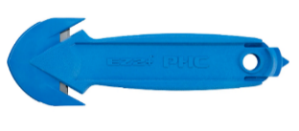  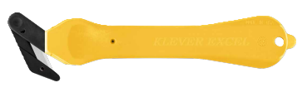 | 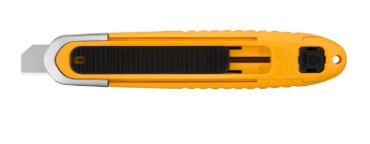  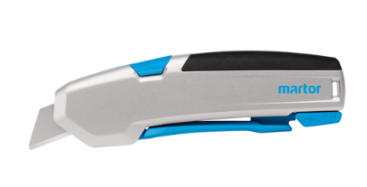

Key Messages
Where are cutting tools used?
- Unpacking deliveries and consumables.
- Workshop and maintenance activities.
- Laboratory and research work.
- Event, exhibition and facilities set-up activities.

What is the risk?
- Cuts and lacerations can occur when blades slip, excessive force is applied, or hands are positioned in the cutting path.
- Many of these injuries are minor, but others are more serious injuries requiring medical treatment.

What can you do?
- Select the safest cutting tool that is appropriate for the task. Consider concealed-blade or auto-retracting safety cutters instead of standard utility knives.
- Select specialist tools for high-volume work
- Replace damaged equipment
- Ensure tools are inspected, maintained and used in accordance with local procedures.
- Complete appropriate training and report injuries and near misses.

Recommendations
- Use micro- or bladeless tools for light cutting tasks; replace standard utility knives and box cutters with concealed-blade or auto-retracting safety cutters where practicable.
- Lightweight tools are fine for occasional use; high-volume tasks require specialised equipment.
- Review local risk assessments and safe work procedures for tasks involving knives and cutting tools.
- Ensure users are trained in the safe use, inspection and maintenance of cutting tools.
- Inspect cutting tools before use, and report or replace damaged or faulty equipment immediately.
- Angle cutting movements away from the body and keep hands and fingers clear of the cutting path.
- Report injuries and near misses through ERMS.

Additional resources:
Look sharp: blade safety when opening packaging (WorkSafe Qld)
KBA eMarket Purchasing Guide
KBA Create non-catalogue purchase requisition

Who to Contact for More Information?
Health and Safety Business Partners: Health & Safety Contacts

