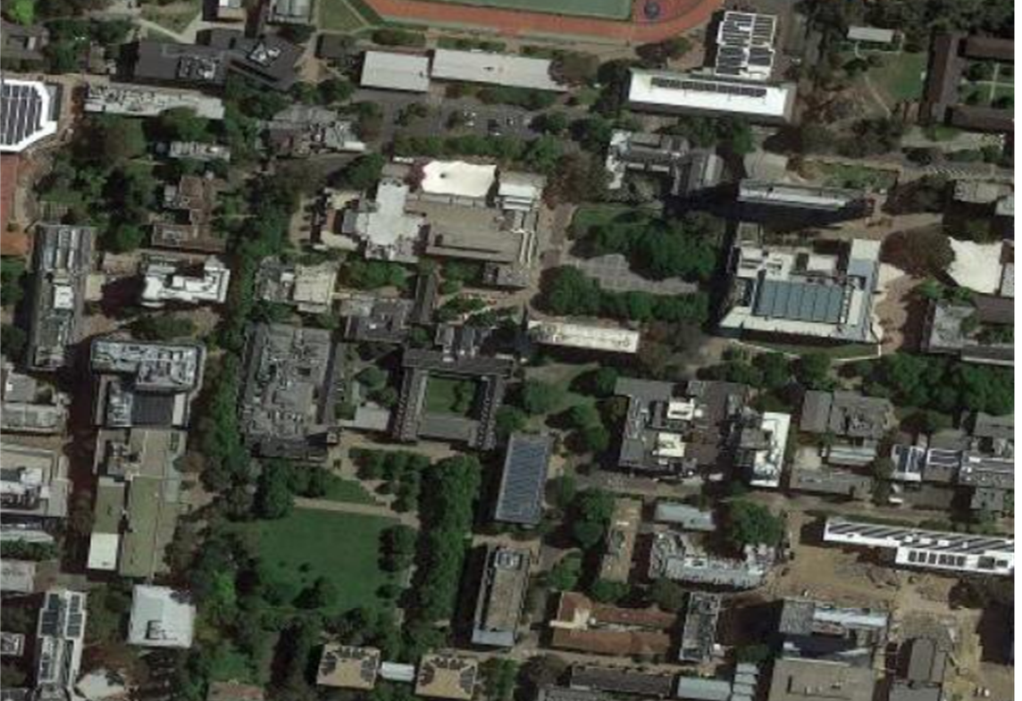

Emergency Management Plan
Parkville Campus
230 Grattan ST
(Grattan ST, Swanston ST, Tin Alley, Royal PDE)

Site details

Item | Description
Site | Parkville
Building | Not applicable – this plan includes all buildings owned and/or operated by the University of Melbourne on the Parkville campus.
Author | Chemical Safety Consultant
Plan Approver | Emergency & Critical Incident Specialist  Assistant Director, Health & Safety
Version | 1.0
Date Approved | September 2021
Next Review Date | September 2026

Authorisation list
Position Title | Name
Chief Warden | Not applicable – Emergency Control Organisations (ECOs) inclusive of chief, deputy and floor/area wardens are in place for individual buildings as required across the Parkville campus.
Deputy Chief | Not applicable – as above.
Emergency & Critical Incident Specialist | Nicky Haslinghouse
Health & Safety Business Partner(s) | Not applicable – a team of Health & Safety Business Partners service individual buildings across the Parkville campus.

Table of Contents
1. Purpose 1
2. Scope 1
3. Location occupancy and functions 1
3.1 Location and occupancy details 1
3.2 Site Infrastructure 2
3.3 Specialist area(s) 2
3.4 Dangerous Goods (DG) 2
3.5 Emergency Assistance 2
3.6 Neighbouring Properties/Buildings 2
4. Management Arrangements 3
4.1 Emergency Planning Committee (EPC) 3
4.2 Emergency Control Organisation (ECO) 3
5. EMERGENCY Resources 4
5.1 Emergency infrastructure 4
5.2 Emergency equipment 4
5.3 Emergency personnel 5
5.4 Personal emergency evacuation plan (PEEP) 5
5.5 Training 5
5.6 Posters, diagrams and checklist 5
5.7 Other Resources 5
6. EMERGENCY procedures 6
6.1 Emergency response procedure (flipchart) 6
6.2 Escalation process 6
6.3 After hours procedure 6
7. Associated Documents and references 6
7.1 Templates and forms 6
7.2 Guidance 6
7.3 Processes and requirements 7
7.4 References 7

Purpose
Health & Safety – Emergency preparedness and response requirements
The purpose of this Emergency Management Plan (EMP) is to provide the Parkville campus with a framework that outlines the resources, procedures and processes required to safely and effectively respond to emergencies.

Scope
This plan includes the structure and duties of the Emergency Planning Committee (EPC) and the Emergency Control Organisation (ECO). The plan also details emergency preparedness information specific to the Parkville campus including detail regarding the personnel, resources, equipment, training and documentation (including as Personal Emergency Evacuation Plans (PEEP).

Location occupancy and functions

Location and occupancy details
Occupancy | Detail
Building layout/characteristics | Parkville campus is the main campus of the University of Melbourne (UoM). It consists of more than 50 buildings of various sizes, heights, designs and ages which host a wide range of business functions including learning and teaching, administration and research.
Location and surrounding buildings/structures etc | The campus is situated between Swanston Street and Royal Parade in Parkville immediately north of the Melbourne CBD. There are UoM owned and operated buildings on the north, south and east side of this campus, three major hospitals (The Women’s Hospital, the Peter MacCallum Comprehensive Cancer Centre, The Royal Children’s Hospital and the Royal Melbourne Hospital, ten residential colleges, several affiliated student accommodation buildings, multiple major research institutes including the Peter Doherty Institute for Infection and Immunity and the Walter and Eliza Hall Research Institute, a significant number of private residences and multiple privately-owned retail outlets situated on and around the main campus.
Access/egress | Main entry points:  - Gate 4 (Monash RD)  - Gate 1 (Tin Alley)  - Gate 11 (On Royal PDE)Gate 10 (Grattan ST)  Please note: this entrance is currently closed to the public and inaccessible by vehicles without a special entry permit granted by the Metro Tunnel Project. Access may be facilitated in an emergency.
Assembly point(s) | When the whole Parkville Campus is evacuated, assembly points will be determined by the critical incident management team in close consultation with emergency services and according to the University of Melbourne Incident Management System (UMIMS). The evacuation of individual buildings and precincts is informed by individual EMPs for those areas as required.
Work area(s) description | While some buildings are used purely for administrative purposes, , as most are used by multiple Faculties, departments and external lease-holders for learning and teaching, administration, public engagement and research activities. Several libraries, museums and performance venues are also located on this campus.
Delivery points | There are numerous delivery points across the campus and within buildings which are articulated within the EMPs of individual buildings and precincts.
Occupancy details (general) | Staff, contractors, students, researchers tenants and members of the public are able to access the main campus at any time due to it being a public institution – in many cases access to buildings is more limited after-hours, and some areas are restricted 24/7 to select users  While the campus is impacted by pandemic restrictions, we expect on any given day there are between 4000 to 8000 people attending the site. This number can vary widely due to the ongoing restrictions and the time of day, but visitation is much lower on weekends and public holidays  When the activities on campus are operating as normal with no restrictions, it is approximated that around 200,000 people attend on-site during the teaching period. This number is reduced by around 20% during non-teaching period (December to March).
Occupancy details (specialist) | Melbourne Brain Centre Imaging Unit provides services to public and is located in the Kenneth Myer Building, Building 144.

Site Infrastructure
Infrastructure | Type | Y/N/NA | Detail
Utilities | Gas/propane | Y | Shut-off location: See attachment 1
 | Water | Y | Shut-off location: See attachment 2
 | Electricity |  | Shut-off location: Each building has its own shut off
 | Solar panel |  | Shut-off location/electrical inverter: N/A
Emergency Power System |  |  | Refer to each building
Boiler Room |  | Y | Refer to each building
Substation |  | Y | See attachment 3

Specialist area(s)
Description | Location
Locations of specialist areas are available online | Link to Parkville maps

Dangerous Goods (DG)
Placard(s) | Location of Emergency Information Book
Several DG are stored in different buildings in Parkville Campus. Detailed information is available in the Emergency Information Books | Gate 11 – On Royal PDE, between the Medical Building and Old Microbiology building  Gate 4 – Monash RD  Gate 1 – Tin Alley

Emergency Assistance
Assistance | Contact
University of Melbourne Security | 03 8344 6666
Emergency Services | 0 000
Poison Information Centre | 13 11 26

Neighbouring Properties/Buildings
- Critical facilities close to proximity of the Parkville campus are:
  - Hospitals:
    - West side: Royal Melbourne Hospital (RMH), Royal Women Hospital (RWH) and Victorian Comprehensive Cancer Centre (VCCC)
    - East side: Royal Dental Hospital of Melbourne (RDHM)
  - The Doherty Institute – south side of Grattan Street

- The Metro Tunnel Project
- UoM buildings on the south side of Grattan Street
- Student accommodations on the east side of the campus
- Few retailers around the campus
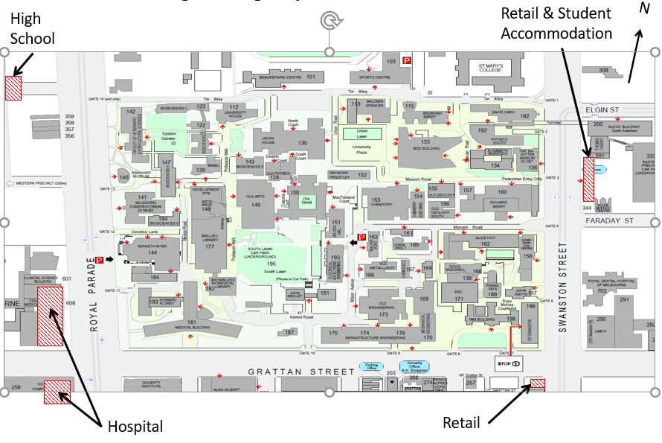

Management Arrangements
As stipulated by the Health & Safety – Emergency preparedness and response requirements, a site may require having an Emergency Planning Committee (EPC). When a site does not have an EPC, the Emergency Control Organisation (ECO) will assume the responsibilities of the EPC of that site.
The Emergency and Critical Incident Specialist will review the EMP to ensure the sufficiency of the EMP for the site.

Emergency Planning Committee (EPC)
The Parkville site does not have an EPC. Each building may have their individual EPC, otherwise the ECO will assume the responsibility of the EPC. The Emergency and Critical Incident Specialist oversees the efficacy of this plan. They will liaise with the EPC or ECO of the individual building and respective departments when necessary.

Emergency Control Organisation (ECO)
ECO is not relevant to the Parkville campus. In an event that full campus is require, this type of incident is managed by Critical Incident Management Team.

EMERGENCY Resources

Emergency infrastructure
Building emergency fittings visual guide
Building infrastructure | Y/N/NA | Remark
Duress Alarm | N/A | Locations: Each building may have duress alarm. Refer to each building EMP.
Emergency Break Glass Alarm | N/A | Refer to each building’s evacuation diagram/EMP
Emergency Warning Intercommunication System (EWIS) | N/A | Refer to each building’s evacuation diagram/EMP
Exit Break Glass Door Release | N/A | Refer to each building’s evacuation diagram/EMP
Fire Break Glass Alarm | N/A | Refer to each building’s evacuation diagram/EMP
Fire hose reel | N/A | Refer to each building’s evacuation diagram/EMP
Fire hydrant | N/A | Refer to each building’s evacuation diagram/EMP
Fire Indicator Panel | N/A | Refer to each building’s evacuation diagram/EMP
Grey box | N/A | Refer to each building’s evacuation diagram/EMP
Smoke and Thermal Fire Detectors | N/A | Refer to each building’s evacuation diagram/EMP
Sprinkler and Suppression System | N/A | Refer to each building’s evacuation diagram/EMP
Warden Intercom Phones (WIP) | N/A | Refer to each building’s evacuation diagram/EMP

Emergency equipment
Building emergency fittings visual guide
Fire extinguisher types and their uses
Emergency equipment are included in the Evacuation Diagrams displayed across the building.
Equipment | Y/N/NA | Remark
Automated External Defibrillator (AED) | Y | Locations: Click here
Fire Blankets | N/A | Refer to each building’s evacuation diagram/EMP
Fire Extinguishers | N/A | Refer to each building’s evacuation diagram/EMP
First Aid Kits | N/A | Refer to each building’s evacuation diagram/EMP

Emergency personnel
Emergency personnel posters are displayed across the building, including at exit points.
Description | Remark
Critical Incident Management Team | This team will manage the emergency involving the whole campus
Security Team | This team is a liaison team between buildings’ Chief Wardens and their Deputies.
Building Chief Wardens and Deputy Chief Warden | List of Chief Wardens are available on Building chief warden list
Floor Wardens | Each building has developed their floor warden structure
First Aiders | First aid assessment form  Based on the First aid risk assessment conducted for this building, the number of First aiders have been appointed and trained.

Personal emergency evacuation plan (PEEP)
Personal emergency evacuation plan
Chief Wardens are to report if there are PEEP in their building.

Training
Personnel | Training required | Resources
Visitors | None | Visitor Emergency Guide
Staff, contractors, relevant students | Health and Safety – Roles and responsibilities | TrainME
 | Local induction | Direct Supervisor
 | Participate in yearly evacuation drill | Chief Warden
Customer facing (e.g. reception, library staff, Health Services) | Suspicious packages | Enrol in TrainME
 | Handling unhappy and angry customers | Enrol in TrainME
Chief Warden, Deputy Chief Warden, Warden | Conduct yearly evacuation drill
 | Fire extinguisher training (elective) | Enrol in TrainME
 | Suspicious packages (elective) | Enrol in TrainME
First Aiders | Provide first aid (Level 2) - HLTAID003 | Enrol in TrainME
 | Provide cardiopulmonary resuscitation (CPR) – HLTAID001 (elective) | Enrol in TrainME

Posters, diagrams and checklist
The Emergency response procedure (Flipchart) is installed across key locations across Parkville campus site.
Evacuation diagram, First Aiders and Warden list posters are also displayed at key common areas.
Forms and Checklists are available on the Emergency preparedness and response web site.

Other Resources
The University Counselling Service and the Employee Assistance Program are available to assist staff who have experienced psychological trauma.

EMERGENCY procedures

Emergency response procedure (flipchart)
The University of Melbourne has considered the emergency code system as per AS 3745. Detailed information on the emergency codes is available on Emergency response procedure (Flipchart) distributed widely across the University.

Escalation process
Health & Safety – Initiate critical incident response
When an emergency cannot be managed by the Chief Warden, the incident may be escalated to the Critical Incident Management Team. Contact University of Melbourne Security for assistance on 8344 6666.

After hours procedure
As a general procedure, when an emergency occurs after hours, a person must contact Security directly and follow any instructions from Security. Individual building may have their own after hours emergency procedure, depending on the nature of their business.

Associated Documents and references

Templates and forms
Bomb/substance and phone threat checklist
Building emergency procedures poster
Building evacuation checklist
Emergency contacts poster
Emergency event report
First aid assessment form
Personal emergency evacuation plan (PEEP)

Guidance
Emergency and first aid website
Emergency preparedness and response web site
Building chief warden list
Building emergency fittings visual guide
Building emergency resources database (Chief warden list)
Fire extinguisher types and their uses
First aid assessment samples
Warden handbook

Processes and requirements
Health & Safety – Establish first aid needs
Health & Safety – Emergency preparedness and response requirement
Health & Safety – Initiate critical incident response
Health & Safety – Responding to an emergency
Emergency response procedure (Flipchart)

References
Occupational Health and Safety Act 2004 (Vic)
AS 3745: Planning for emergencies in facilities
Compliance Code: First aid in the workplace (Vic)

Attachment

Attachment 1 Gas Isolation Points

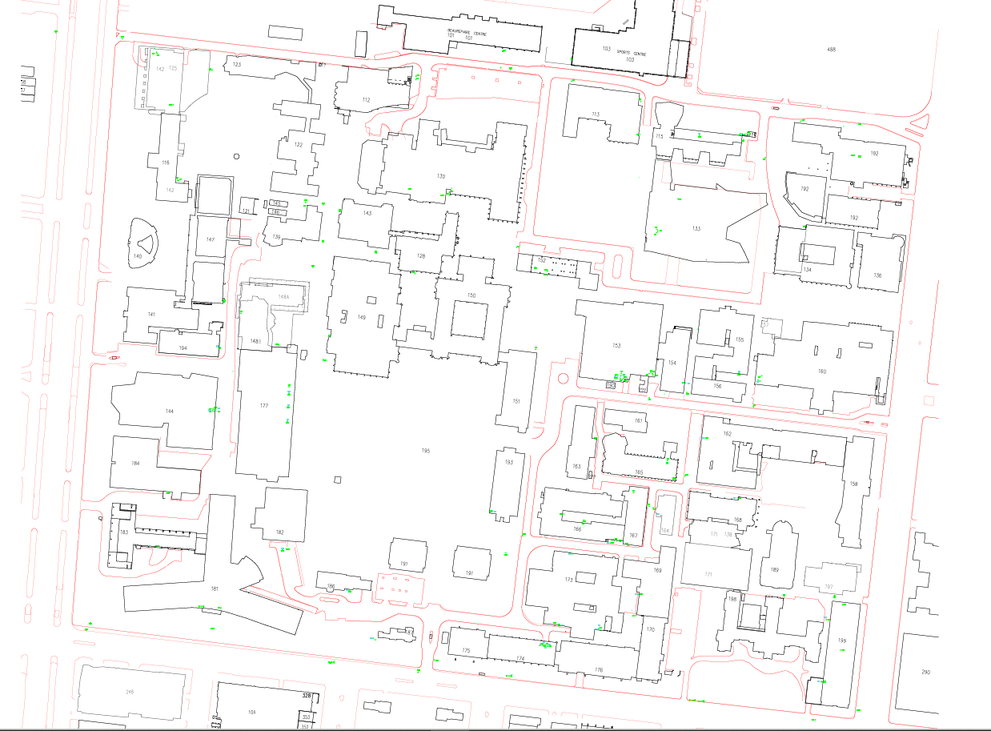

Attachment 2 Water Isolation Points

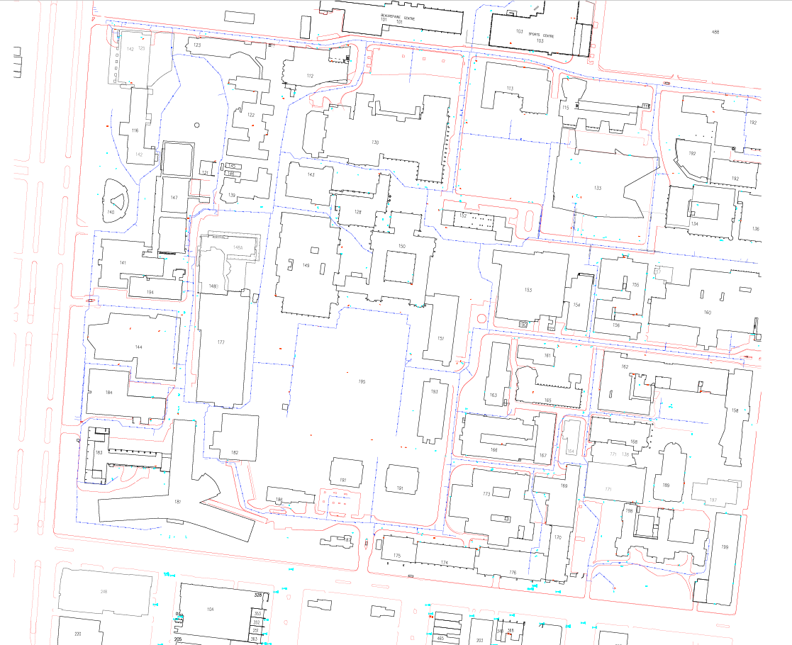

Attachment 3 Substation locations

Building number | Building name | Room number | Remark
101 | Beaurepaire Centre | B03
115 | Redmond Barry building | B11
125 | Building 125 | B129
130 | Union House | B12B
144 | Kenneth Myer building | G16
148B | Art West building (West wing) | B203B
152 | Raymond Priestley Building | B32
153 | Chemistry building (West) | B18
158 | Sidney Myer Asia Centre | BM3
162 | Alice Hoy | 131
163 | Walter Boas building | B05
168 | Doug McDonell building | 103
169 | Engineering Workshops | G09
177 | Baillieu library | S01
181 | Medical building | N110
181 | Medical building | N110A
181 | Medical building | N110B | Spare switch room and for 144
189 | Frank Tate building | 117
191 | John Medley building | B07
192 | David Caro building | 66
193 | Electrical & Electronic building | 105

An EPC is responsible for the documentation and maintenance of an emergency plan (this document and associated activities). An EPC is not required for every building location. For buildings where there is not an EPC, the ECO will assume the responsibilities of the EPC.
An ECO is responsible for directing and controlling the implementation of the emergency response procedures.

