health & safety
building emergency fittings – visual guide

FITTING | DESCRIPTION
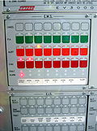 | Emergency Warning Intercommunications System (EWIS)  Most multi-story buildings at the University have an emergency warning intercommunications system. It warns occupants of an emergency and advises them to evacuate. It is usually on the ground floor near the fire information panel.
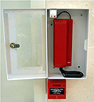 | Warden Intercom Phones (WIP)  Warden intercom phones are located throughout a building and designed to be used by wardens or trapped building occupants. These phones are connected to the EWIS and can be used to communicate between floors or zones.  Note: You cannot make an external call using these phones.
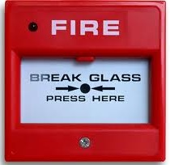 | Fire Break Glass Alarm (BGA)  Buildings fitted with a fire break glass alarm allow occupants to activate the fire alarm and alert the fire brigade easily. The red panel on the wall houses a small button that when depressed will contact the Fire Brigade. The Fire Brigade will respond instantly to the building.  The glass, or Perspex material is easy to break with your fist, elbow or a pen. Breaking the glass will sometimes activate the button automatically.
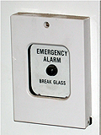 | Emergency Break Glass Alarm  A building may have an emergency break glass alarm. These break glass alarms buttons are different to the fire break glass alarm because they do not contact the Fire Brigade. The emergency break glass alarm activates the EWIS to initiate an evacuation of the building.  In some situations you may not need to contact the Fire Brigade but do need to evacuate the building. This is where the emergency break glass alarm can help.
Exit Break Glass Door Release
Exit Break Glass Door Releases are usually fitted to emergency exit doorways in higher security areas.
Exit Break Glass Door Releases allow the access control on an otherwise secure door to be overridden for emergency egress. Simply break the glass (this is usually actually just a plastic cover) and the door will unlock.
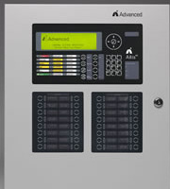 | Fire Indicator Panel  The fire indicator panel is the hub of the fire alarm system in a building. It is usually located on the ground floor near an entrance close to the nearest road. The panel may be located in a cabinet or on a wall. On the panel is a number of lights and buttons. These lights indicate which fire sensor has activated in the building.  The fire indicator panel will automatically notify the fire brigade of an alarm when one of its sensors locates a fire. The fire indicator panel will usually talk to the EWIS (where installed) and notify the building occupants that they need to evacuate.  Fire indicator panels can look very different from one building to the next.
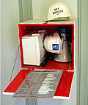 | Chief Warden Equipment Box  Some buildings have made their own equipment box to house the response equipment for the Chief Warden such as a first aid kit, megaphone, clipboard and checklists, spare helmets, etc. This is an excellent idea and will ensure all the required equipment is at the Warden meeting point for use. If your building has a box like this, please contact your Chief Warden for queries regarding it.
Emergency Exit Sign
Emergency exits are identified by a green illuminated sign bearing the international symbol for EXIT. These exit signs point to a path out of the building.
In halls and corridors, an exit sign will have an arrow indicating which way people should head to find the emergency exit door or emergency stairs.
Most emergency exit signs have a battery backup system to keep them illuminated after the power has failed. The battery lasts long enough for all building occupants to evacuate safely.
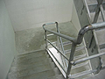 | Emergency Stairs  During an evacuation building occupants need an escape route that is protected from fire and smoke. In multi-story buildings fire escapes are installed. These escape stairs are more fire and smoke free because of their solid construction and fire rated doors.  The fire escape stairs typically lead to a ground floor exit door. The stairs should be wide with enough room for all building occupants to walk down safely. In some older buildings the fire escape stairs have been added to the building externally. They are usually made from metal. Older wooden ones will be replaced over time.
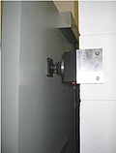 | Fire Door Release  During an evacuation, fire doors should be closed to prevent fire and smoke movement through the building.  Fire door releases hold doors open during the day for normal use, then release them when the fire alarm system activates.  Press the red button under the release mechanism to release the doors manually.
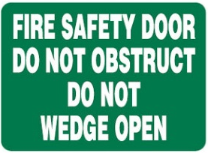 | Fire safety door: do not obstruct  These doorways are designed to protect building occupants in the case of a fire. They must never be blocked in any circumstances.  Unless fitted with a door release, they must remain closed at all times.
Fire Extinguishers
Fire extinguishers are portable appliances used to attend a small fire during its initial stage. They should only be used if safe to do so.
There are different types of extinguishers for different types of fires. For more information on types of extinguishers refer to Fire extinguisher types and their uses.
Always call or alert emergency services if you need to use a fire extinguisher.
For more information about types of fire extinguishers
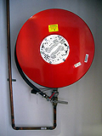 | Fire Hose Reels  Fire hose reels are in signed cupboards within buildings. They are used by trained personnel only in the vent of fire.  It is important that the cupboards are not used for storage of any items and that the cupboard door is not obstructed.
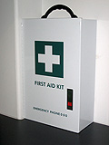 | First Aid Kits  Safety kit for the provision of emergency treatment and life support for people suffering injury or illness in the workplace.  General guidance about first aid and first aid kits is available from First aid.  These kits are purchased and managed individually by local areas. Please contact your local supervisor or your Health and Safety Business Partner for queries.
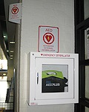 | Automated External Defibrillator (AED)  Equipment to provide first aid to a person experiencing suspected sudden cardiac arrest (heart attack). Training is recommended before using them, but not required. Please follow the instructions packaged with the machine, as well as the standard operating procedure.  Locations of Automated External Defibrillators at Parkville and Southbank
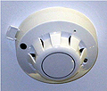 | Smoke and Thermal Fire Detectors  The detection system in buildings may sense either heat or smoke or a combination of these. Smoke detectors are increasingly being used because of their early warning of an emergency situation.  Smoke detectors may also be used to activate fire doors to isolate zones in the building.
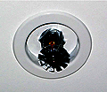 | Sprinkler and Suppression Systems  Sprinkler system  Some areas are fitted with automatically activated sprinkler heads. On activation, the sprinklers discharge water to extinguish/contain a fire.  Suppression system  In some locations (such as flammable liquids storerooms or computer server rooms), gaseous or foam suppression systems are used instead of water. Where a suppression system is installed in an area that is normally occupied, you will hear a warning alarm before the discharge of gas or foam into the room.
Buildings with an area of refuge should be included on evacuation the building evacuation diagram. | Area of refuge  An area of refuge is a location in a building designed to hold occupants during a fire or other emergency, when evacuation may not be safe or possible.  This may include fire-rated stairwells or other purpose built spaces.

