health & safety
EYE protective equipment – selection and use
- Purpose
To select the most suitable type of eye protective equipment whilst carrying out various hazardous activities where there is a risk of injury to the eyes and/or face.
- Selecting the appropriate type of safety glasses
- All types of eye protective equipment must comply with Australian Standard AS/NZS 1337 – Eye Protectors for Industrial Applications. This guideline will outline other Australian standards that are applicable in selecting various types of eye protective equipment.
- Always consider other forms of controls first, this should be documented in your Risk Assessment or Standard Operating Procedure (SOP). Personal Protective Equipment (PPE) is the lowest order risk control and is the last line of defence. Are higher order risk controls available to further reduce eye damage risks?
- When selecting eye protective equipment there are a number of factors that need to be considered:
  - The work environment and the potential hazards that you are exposed to, which will help determine the most appropriate type of eye protective equipment.
  - Some eye protective equipment is designed to protect you from dust and low risk particulates and projectiles, whilst others are designed to protect you from lasers and high risk particulates and projectiles.
- Ensure the eyewear fits well
  - Must cover entire eye area
  - Must have side shielding
  - Should be snug to your face, no more than a little finger gap between the glasses and your cheeks or forehead
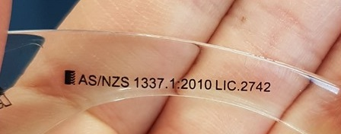
  - Must not restrict vision and/or movement and should not interfere with the task
- Ensure the eyewear is fit for the purpose. Ensure the lens markings match the hazards.

Lens Marking | Type of Lens
I | Medium impact
V | High impact
M | Molten metal & hot solid resistant
O | Outdoor use, untinted
A | Extra high impact

The Australian Standard marking on safety eyewear.

Special note to contact lens wearers
Some chemicals you work with can become trapped between the contact lens and the cornea causing significant eye damage. It is not just splashes of liquids but some chemical fumes/vapours also present this hazard. For this reason it is recommended people who wear contact lenses to follow one of these options:
- Use safety goggles rather than safety glasses to decrease likelihood of chemical contact with your eye; or
- Remove contact lenses and use prescription safety glasses or over-glasses over your spectacles.
- Care and Maintenance of safety eyewear
- Scratches can impair your vision and the integrity of the eye protective equipment. Ensure your eye protective equipment is stored in an area where they will be free from scratches, dust, or any other damage.
- Prior to using any type of eye protective equipment it is important that you inspect them to ensure they are in working order and are free from scratches, cracks or any other visible damage.
- If the eye protective equipment is damaged in any way you must tag them out of service and notify your supervisor as soon as possible.

- Eye protective equipment – quick reference guide
 | Safety Glasses | Prescription Safety Glasses* | Over-glasses | Sun Glasses** | Vented Safety Goggles | Sealed Safety Goggles | Laser Glasses of Goggles | Full Face Shield | Welding Mask | Gas Welding Goggles | Full Face Respirator
High density airborne particulates
Medium density airborne particulates
Low density airborne particulates
Medium to high velocity projectiles
Low to medium velocity projectiles
High likelihood of splashes of liquid in eyes
High likelihood of splashes of liquid in eyes and face
Medium likelihood of splashes of liquid in eyes
Low likelihood of splashes of liquid in eyes
Splashes of liquids of high consequence materials in eyes
Splashes of liquids of high consequence materials in eyes and face
Splashes of liquid of low consequence materials in eyes
Splashes of high risk biological or infectious agents into the eyes
Splashes of high risk biological or infections agents into the eyes and face
Splashes of medium risk biological or infectious agents into the eyes
Splashes of low risk biological or infectious agents into the eyes
Aerosols/mists
Fumes/vapours
Working with gel electrophoresis and Ultraviolet transilluminators used to visualise fluorescent markers
Unshielded Class 3B and greater lasers
Laser scatter from partially shielded Class 3B and greater lasers
UV Exposure from sun/working outdoors
When using ARC, TIG, MIG or other electric arc creating welding processes
When suing gas cutting or welding techniques with Oxy Acetylene equipment
Dusts, mists, aerosols, fumes and/or vapours that are also hazardous to the lungs

Legend
Preferred
Adequate
Fair

* Refer to Section 5 for more information with regards to using prescription safety glasses.
** Sun glasses are only suitable for outside use, and are not designed to be worn whilst performing welding activities or whilst operating a laser.

- Eye protective equipment – detailed reference guide
Eye Protection Types |  | When to Wear |  | Things to Consider When Selecting | Constraints of Use | Legal and Other Information
Safety Glasses |  | 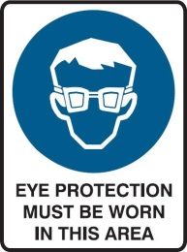 | Where there is a risk of:  - Low density airborne particulates  - Low likelihood of splashes of liquid in eyes  - Low to medium velocity projectiles  - Splashes of liquids of low consequence materials in eyes  - Splashes of low risk biological or infectious agents into the eyes | - These will only provide eye protection against foreign objects that are directed toward the face; there is a chance that objects can get in under and around the glasses. | Do not adequately control eye related risks from:  - Liquids from reaching the eye  - Aerosols, mists or vapours  - High density airborne particulates  Consider using Safety Goggles or Face Shield when working with the above hazards | - Must conform to Australian Standard AS/NZS 1337  - AS/NZS marking can be found on the arm or lens of all certified safety glasses  - AS/NZS1336 provides useful information regards:  - Section 4.2 - selecting the type of eyewear for particular hazards  - Section 4.3 – fitting  - Section 4.4 – fogging issues  - Section 4.5 – maintenance and care
Prescription Safety Glasses |  |  | Where there is a risk of:  - Low density airborne particulates  - Low likelihood of splashes of liquid in eyes  - Splashes of liquids of low consequence materials in eyes | Type 1 (first photo)  - If working with projectile hazards consider the need for alternate risk control such as Over-glasses, Safety Goggles or Face Shield.  - The lenses and their method of securing in the frame are not rated to AS/NZS1337 requirements as your optometrist cannot test/certify to these standards.  Type 2 (second photo)  - This type of prescription safety glasses utilises a prescription insert behind an AS/NZS 1337 compliant safety glasses.  - Same fit and AS/NZS marking requirements as Safety Glasses. | Do not adequately control eye related risks from:  - Medium or High Impact projectiles  - Liquids from reaching the eye  - Aerosols, mists or vapours  - High density airborne particulates  Consider using Over-glasses, Safety Goggles or Face Shield when working with the above hazards | - Must conform to Australian Standard AS/NZS 1337.6  - AS/NZS1336 provides useful information regards:  - Section 4.2 - selecting the type of eyewear for particular hazards  - Section 4.3 – fitting  - Section 4.4 – fogging issues  - Section 4.5 – maintenance and care
Over-glasses |  |  | Where there is a risk of:  - Low density airborne particulates  - Medium to high velocity projectiles  - Low likelihood of splashes of liquid in eyes  - Splashes of liquids of low consequence materials in eyes  - Splashes of low risk biological or infectious agents into the eyes | - These should be considered as a preferred risk control over Prescription Safety Glasses for working with projectile hazards as they are tested to and conform to the relevant Australian Standards.  - Same fit and AS/NZS marking requirements as Safety Glasses. | Do not adequately control eye related risks from:  - Liquids from reaching the eye  - Aerosols, mists or vapours  - High levels of airborne particulates  Consider using Safety Goggles or Face Shield when working with the above hazards. | - Must conform to Australian Standard AS/NZS 1337  - AS/NZS marking can be found on the arm or lens of all certified safety glasses  - AS/NZS1336 provides useful information regards:  - Section 4.2 - selecting the type of eyewear for particular hazards  - Section 4.3 – fitting  - Section 4.4 – fogging issues  - Section 4.5 – maintenance and care
Sun Glasses |  | No specific signage used to indicate when to wear. | Where there is a risk of:  - UV exposure from sun/working outdoors | - Standard sun glasses as purchased from eyewear outlets are not Safety Glasses as they do not conform to the AS/NZS1337 requirements for protective qualities.  - Ensure Sun Glasses are AS1067 complaint (UV protection).  - Consider further needs such as Polarisation of lenses to help reduce eye fatigue.  - Safety Sun Glasses are available from safety product providers and have same fit and AS/NZS marking requirements as Safety Glasses.  - Not suitable for laboratory work unless AS1337 compliant, although it is not recommended to wear Sun Glasses indoors. | Do not adequately control eye related risks from:  - Lasers – use specialised Laser Safety Glasses  - Welding – use specialised Welding Masks  - Liquids from reaching the eye  - Aerosols, mists or vapours  - High levels of airborne particulates  Consider using a Face Shield over Sun Glasses when working with the above hazards. | - Safety Sun Glasses must conform to Australian Standard AS1067 and AS/NZS 1337  - AS/NZS marking can be found on the arm or lens of all certified safety glasses  - AS/NZS1336 provides useful information regards:  - Section 4.2 - selecting the type of eyewear for particular hazards  - Section 4.3 – fitting  - Section 4.4 – fogging issues  - Section 4.5 – maintenance and care
Vented Safety Goggles |  | 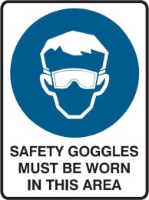 | Where there is a risk of:  - Low density airborne particulates  - Medium likelihood of splashes of liquid in eyes  - Splashes of liquids of low consequence materials in eyes  - Splashes of medium risk biological or infectious agents into the eyes | - Note the pictures to the left show Safety Goggles with large vents in the sides that are to help prevent the Goggles from steaming up and/or allow ventilation to the face/eye area of the user. These vents also allow hazardous materials into the Goggles. | Do not adequately control eye related risks from:  - Aerosols, mists or vapours  - High levels of airborne particulates  Consider using Sealed Safety Goggles when working with the above hazards | - Must conform to Australian Standard AS/NZS 1337.  - AS/NZS marking can be found on or near the lens of all certified safety goggles.  - AS/NZS1336 provides useful information regards:  - Section 4.2 - selecting the type of eyewear for particular hazards  - Section 4.3 – fitting  - Section 4.4 – fogging issues  - Section 4.5 – maintenance and care
Sealed Safety Goggles | 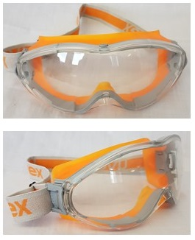 |  | Where there is a risk of:  - Medium density airborne particulates  - Medium or high velocity projectiles  - Splashes of liquids of high consequence materials in eyes  - High likelihood splashes of liquids in eyes  - Aerosols/mists  - Fumes/vapours  - Splashes of high risk biological or infectious agents into the eyes | - Ensure that the seal surface is in full contact with the face to provide adequate sealing of the inside of the Goggles.  - If the Goggles are too big for your face (there are gaps in the seals), consider combining with use of a Face Shield.  - Ensure hair is kept out from inside the goggles. Hair under the seal surface compromising the integrity of the seal. | Do not adequately control risks from:  - Large splashes impacting face  - Medium or high velocity projectiles striking face  Consider using a Face Shield when working with the above hazards | - Must conform to Australian Standard AS/NZS 1337.  - AS/NZS marking can be found on or near the lens of all certified safety goggles.  - AS/NZS1336 provides useful information regards:  - Section 4.2 - selecting the type of eyewear for particular hazards  - Section 4.3 – fitting  - Section 4.4 – fogging issues  - Section 4.5 – maintenance and care
Laser Safety Glasses or Goggles |  |  | Where there is a risk of:  - Unshielded Class 3B and greater lasers.  - Laser scatter from partially shielded Class 3B and greater lasers. | - Ensure protection is adequate for the correct wavelength of the laser.  - Ensure that wearers undertake regular, specialised laser eye health checks. | Do not adequately control risks of:  - Welding – use specialised Welding Masks
Full Face Shield |  | 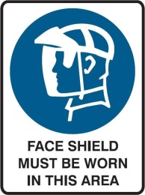 | Where there is a risk of:  - High density airborne particulates  - Medium or high velocity projectiles  - Splashes of liquids of high consequence materials in eyes and face.  - High likelihood splashes of liquids in eyes and face.  - Aerosols/mists  - Splashes of high risk biological or infectious agents into the eyes and face.  - When working with gel electrophoresis and Ultraviolet transilluminators used to visualise fluorescent markers | - Face shields come in many different shapes and materials, each one having a specific quality the others don’t. Be sure to select the Face Shield that best suits the risks you are controlling.  - When working with dust, aerosols, mists, fumes or vapours that have high consequences to eyes, consider “doubling up” by wearing Sealed Safety Goggles under your Full Face Shield.  - The transilluminators’ manufacture’s specifications should be consulted for information as to the potential exposure level and frequency of radiation and their suggested operating protocols | Do not adequately control risks of:  - Welding, no matter how darkly tinted – use specialised Welding Masks | - Must conform to Australian Standard AS/NZS 1337.  - AS/NZS marking can be found on the frame or lens of all certified Face Shields.  - AS/NZS1336 provides useful information regards:  - Section 4.2 - selecting the type of eyewear for particular hazards  - Section 4.3 – fitting  - Section 4.4 – fogging issues  - Section 4.5 – maintenance and care
Welding Mask | 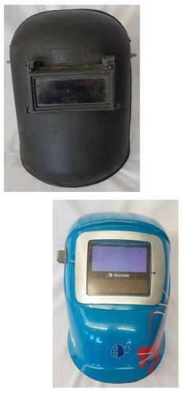 | 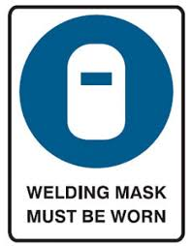 | When using ARC, TIG, MIG or other electric arc creating welding processes. | - The darkness of the vision panel comes in various levels of light intensity protection. Ensure you have the correct level of protection for the type of welding you are undertaking. |  | - Must conform to Australian Standard AS/NZS 1337 and AS/NZS 1338.
Gas Welding Goggles | 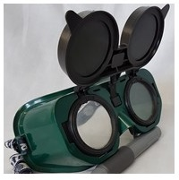 | No specific signage used to indicate when to wear. | When using gas cutting or welding techniques with Oxy Acetylene equipment. | - Nil | Do not adequately control risks of:  - Electric Arc Welding, no matter how darkly tinted – use specialised Welding Masks | - Must conform to Australian Standard AS/NZS 1337 and AS/NZS 1338.
Full Face Respirators | 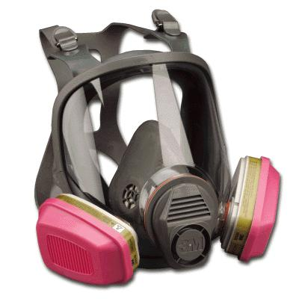 | 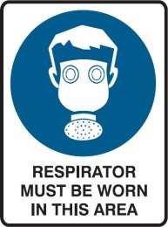 | Where there is a risk of:  - Dusts, mists, aerosols, fume or vapours that are also hazardous to lungs. | - Refer to Respiratory protective equipment selection and use for further guidance regarding the respiratory protective qualities of this type of PPE. |  | - Must conform to Australian Standard AS/NZS 1337 for eye protection.  - Must conform to Australian Standard AS/NXS 1716 for respiratory protection.

