
HEALTH & SAFETY
HAZARDOUS WASTE GUIDANCE SHEET
This table is to provide a quick reference guide to the classification, packaging and storage of hazardous waste, after consulting with the chemical’s Safety Data Sheet
Important information in preparing the hazardous waste is available in the Safety Bulletin page - Topic: Hazardous Waste Safety, Nitric Acid
For additional information on waste contractor arrangements and collection, refer to: Hazardous waste.

UNIVERSITY HAZARDOUS WASTE PICK UP (NO PURCHASE ORDER REQUIRED – COSTS COVERED BY HEALTH & SAFETY HAZARDOUS WASTE SERVICE AGREEMENT) – CAT 1
Cat 1 waste are waste products of laboratory activities from both research and teaching
Category | Definition | Container: Description, photo | Label | Further information
Hydrocarbon waste | Hydrocarbon based waste contains organic compound, which may be diluted in water.  Common examples:  Acetone, Acetonitrile, Dimethylformamide, Ethanol, Methanol, Propanol, Benzene, n- Butanol, Butyl Acetate, Diethyl ether, Ethyl acetate, Heptane, Hexane, Pentane, Petroleum spirits, Toluene, Turpentine | Use 10L HDPE plastic carboy with approved lid; DG and UN approved; Must be compatible with the primary solvent.  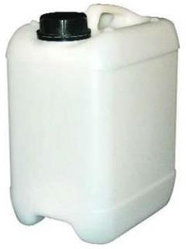 | Affix this label on the carboy and provide information on the chemical name/s and estimated concentration  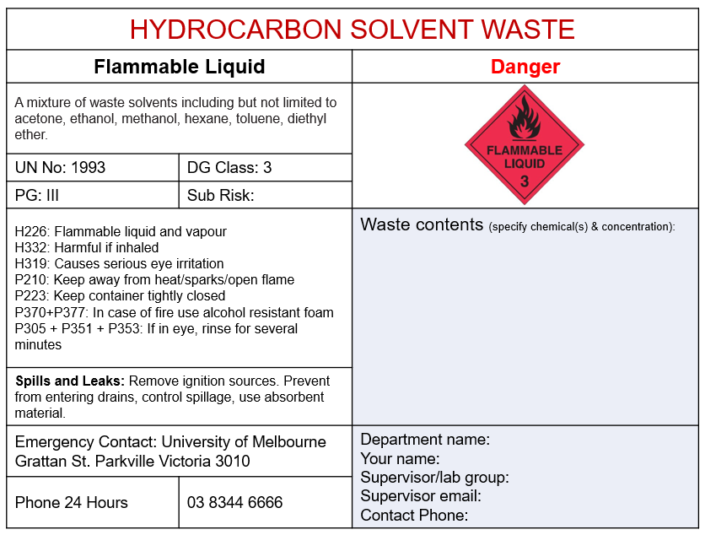 | Remove the ring of the lid before using the carboy.  The carboy should only be filled to the shoulder. The lid must be tightly sealed.  Check for leaks – if leaking, the contents must be decanted into a new carboy.  Carboy will be supplied by the waste contractor. Do not use Schott bottles or glass for any waste.  Outcome: Energy recovery
Halogenated hydrocarbon waste | Halogenated hydrocarbons are compounds that contain carbon and hydrogen atoms with one or more hydrogen atoms replaced by halogen atoms (fluorine, chlorine, bromine or iodine).  Common examples:  1,2-dichloroethane; Chloroform; Dichloromethane, carbon tetrachloride  Exception for compounds that must not be put in this category  - Inorganic halogen, especially hypochlorite products, hydrogen fluoride  - Pesticide & herbicides | Use 10L HDPE plastic carboy with approved lid; DG and UN approved; Must be compatible with the primary solvent | Affix this label on the carboy and provide information on the chemical name/s and estimated concentration  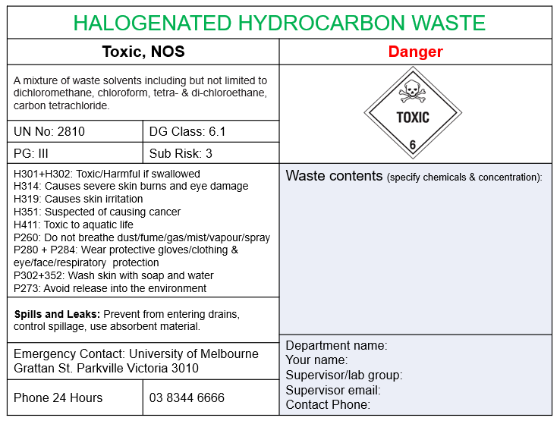 | Remove the ring of the lid before using the carboy.  The carboy should only be filled to the shoulder. The lid must be tightly sealed.  Check for leaks – if leaking, the contents must be decanted into a new carboy.  Carboy will be supplied by the waste contractor. Do not use Schott bottles or glass for any waste.  Outcome: Energy recovery

UNIVERSITY HAZARDOUS WASTE PICK UP (NO PURCHASE ORDER REQUIRED – COSTS COVERED BY HEALTH & SAFETY HAZARDOUS WASTE SERVICE AGREEMENT) – CAT 1
Cat 1 waste are waste products of laboratory activities from both research and teaching
Category | Definition | Container: Description, photo | Label | Further information
Strong acid waste | Chemical waste where the major component has a pH <4  Common examples: concentrated sulphuric acid, hydrochloric acid, non-fuming nitric acid  Common chemicals with pH 5 to 10 are classed as general waste unless they are heavy metals or contain other materials that cannot go down the drain. If in doubt, dispose as custom waste (see below)  Note:  - Do not mix Nitric Acid with other acids, flammable solvents, or any other incompatible substances.  - Some acids are also oxidisers (nitric acid fuming) or flammable (acetic acid glacial)  - Hydrofluoric acid must be managed separately. | Use 10L HDPE plastic carboy with approved lid;. DG and UN approved; Must be compatible with the primary solvent | Affix this label on the carboy and provide information on the chemical name/s, estimated concentration and pH  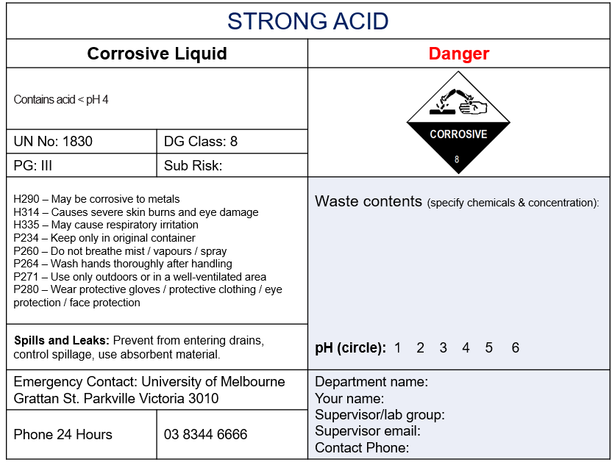 | Remove the ring of the lid before using the carboy.  The carboy should only be filled to the shoulder. The lid must be tightly sealed.  Check for leaks – if leaking, the contents must be decanted into a new carboy.  Carboy will be supplied by the waste contractor. Do not use Schott bottles or glass for any waste.  Outcome: Chemical treatment
Strong Alkali waste | Chemical waste where the major component has a pH >10  Common examples: hypochlorite waste, potassium hydroxide, sodium hydroxide concentrate  Common chemicals with pH 5 to 10 are classed as general waste unless they are heavy metals or contain other materials that cannot go down the drain. If in doubt, dispose as custom waste. | Use 10L HDPE plastic carboy with approved lid; DG and UN approved; Must be compatible with the primary solvent | Affix this label on the carboy and provide information on the chemical name/s, estimated concentration and pH  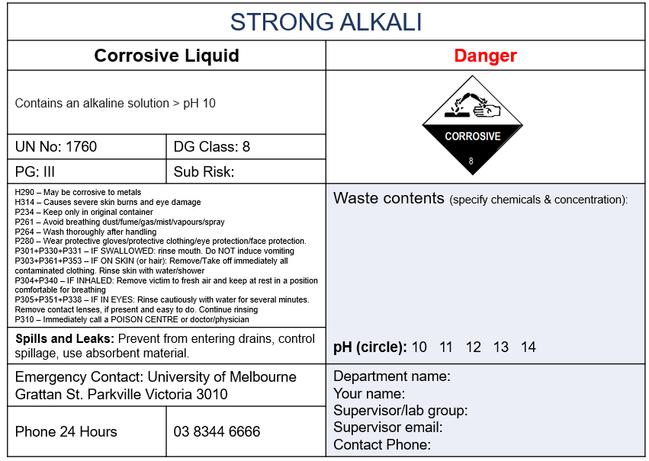 | Remove the ring of the lid before using the carboy.  The carboy should only be filled to the shoulder. The lid must be tightly sealed.  Check for leaks – if leaking, the contents must be decanted into a new carboy.  Carboy will be supplied by the waste contractor. Do not use Schott bottles or glass for any waste.  Outcome: Chemical treatment

UNIVERSITY HAZARDOUS WASTE PICK UP (NO PURCHASE ORDER REQUIRED – COSTS COVERED BY HEALTH & SAFETY HAZARDOUS WASTE SERVICE AGREEMENT) - CAT 1
Cat 1 waste are waste products of laboratory activities from both research and teaching
Category | Definition | Container: Description, photo | Label | Further information
Heavy metal waste | Heavy metal waste from laboratory processes may be in a water soluble or insoluble phase  Common examples:  copper sulphate, zinc chloride, mercury, cadmium and lead | Use carboy 10L; HDPE plastic with approved lid; DG and UN approved; Must be compatible with the primary solvent  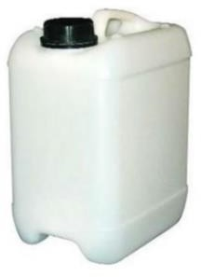 | Affix this label on the carboy and provide information on the chemical name/s, estimated concentration and pH  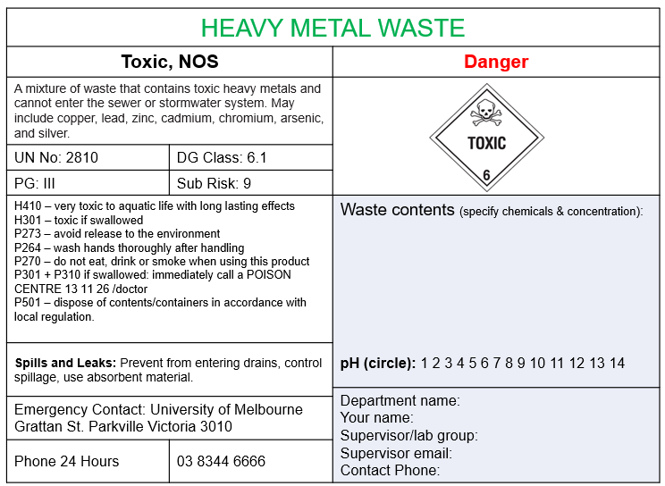 | Remove the ring of the lid before using the carboy.  The carboy should only be filled to the shoulder. The lid must be tightly sealed.  Check for leaks – if leaking, the contents must be decanted into a new carboy.  Carboy will be supplied by the waste contractor. Do not use Schott bottles or glass for any waste.  Outcome: Energy recovery/Chemical treatment
Oxidiser waste | Waste that is classified as an oxidiser, identified as a DG 5.1.  This waste can react violently with flammables or organic compounds.  Common examples:  Peroxides, nitrates, permanganates, chlorates, concentrated hydrogen peroxide. | Use carboy 10L; HDPE plastic with approved lid; DG and UN approved; Must be compatible with the primary solvent | Affix this label on the carboy and provide information on the chemical name/s and estimated concentration  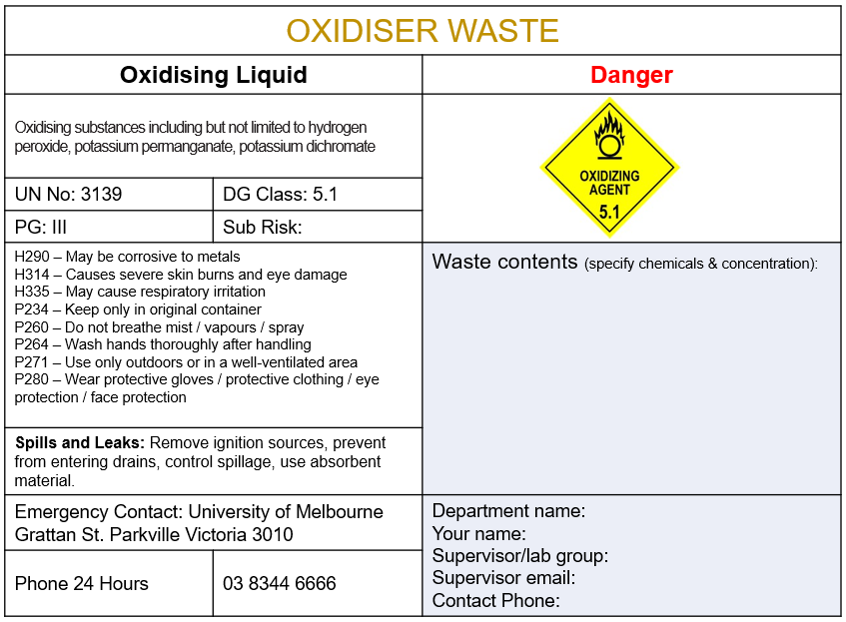 | Remove the ring of the lid before using the carboy.  The carboy should only be filled to the shoulder. The lid must be tightly sealed.  Check for leaks – if leaking, the contents must be decanted into a new carboy.  Carboy will be supplied by the waste contractor. Do not use Schott bottles or glass for any waste.  Any reactions must be allowed to progress before sealing the carboy—otherwise unsafe pressure may develop in the container.  Keep away from flammables  Outcome: Chemical treatment
Developer waste | Solutions used in the development of photographs and X-ray film are treated as silver rich spent solutions | Use 10L HDPE plastic with approved lid; DG and UN approved; Must be compatible with the primary solvent | Affix this label on the carboy  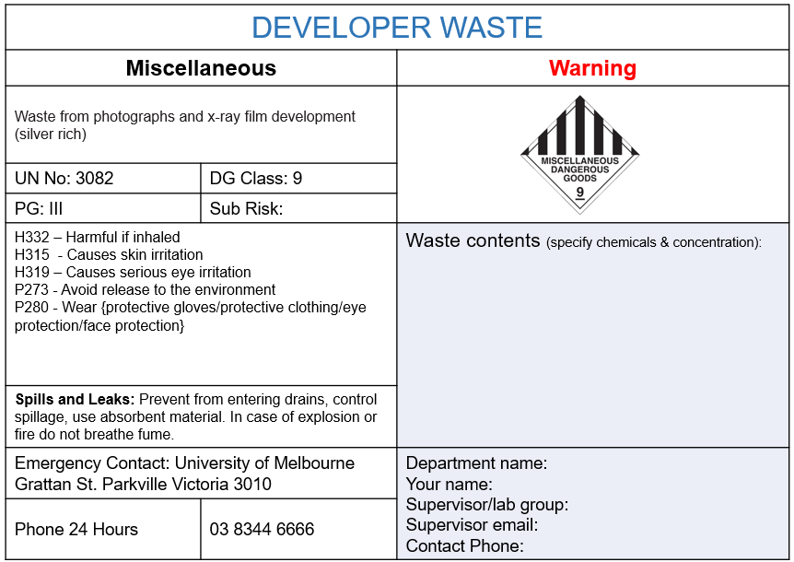 | Remove the ring of the lid before using the carboy.  The carboy should only be filled to the shoulder. The lid must be tightly sealed.  Check for leaks – if leaking, the contents must be decanted into a new carboy.  Carboy will be supplied by the waste contractor. Do not use Schott bottles or glass for any waste.  Outcome: Recycled
Pesticide and herbicide waste | Pesticide waste from laboratory processes will usually be in the water-soluble phase. It may be generated from plant labs or aquatic labs  Note:  Chlorinated pesticide (organochlorine) like DDT (Dichlorodiphenyltrichloroethane) must be separated from other pesticides/herbicides. | Use 10L HDPE plastic carboy with approved lid; DG and UN approved; Must be compatible with the primary solvent  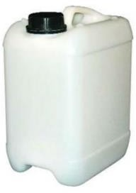 | Affix this label on the carboy and provide information on the chemical name/s and estimated concentration  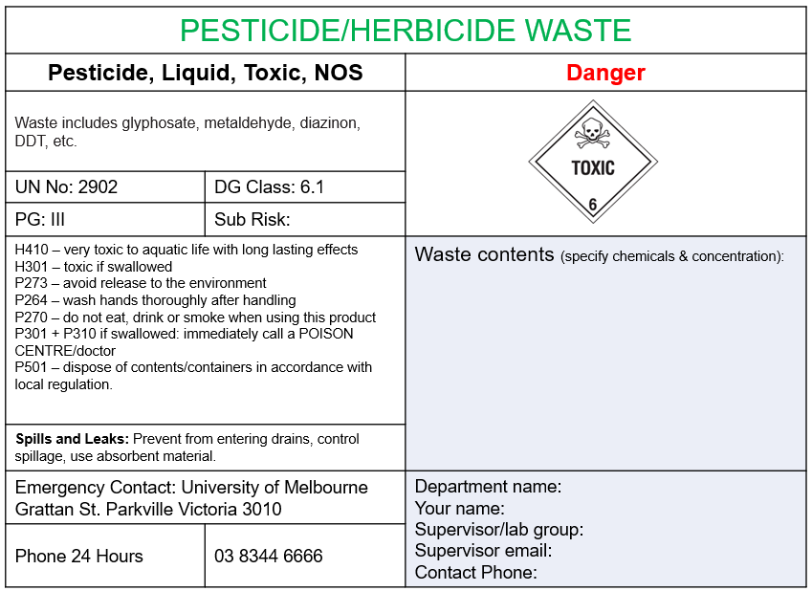 | Remove the ring of the lid before using the carboy.  The carboy should only be filled to the shoulder. The lid must be tightly sealed.  Check for leaks – if leaking, the contents must be decanted into a new carboy.  Carboy will be supplied by the waste contractor. Do not use Schott bottles or glass for any waste.  Outcome: Incinerated
Cytotoxic | The term cytotoxic is used to describe materials that are destructive to cells. Cytotoxic waste includes any unwanted cytotoxic drug preparations, disposable laboratory consumables and sharps that may have been contaminated with cytotoxic material, and the carcasses of animals treated with cytotoxic drugs and associated animal bedding.  Common examples: ethidium bromide, chemotherapy drugs | 20L purple pail with white lid, 20L white pail with label, or 240L purple bin  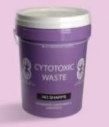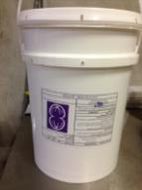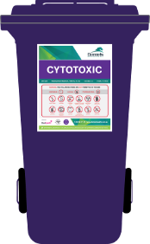 | Affix this label on the carboy and provide information on the chemical name/s and estimated concentration (if applicable)  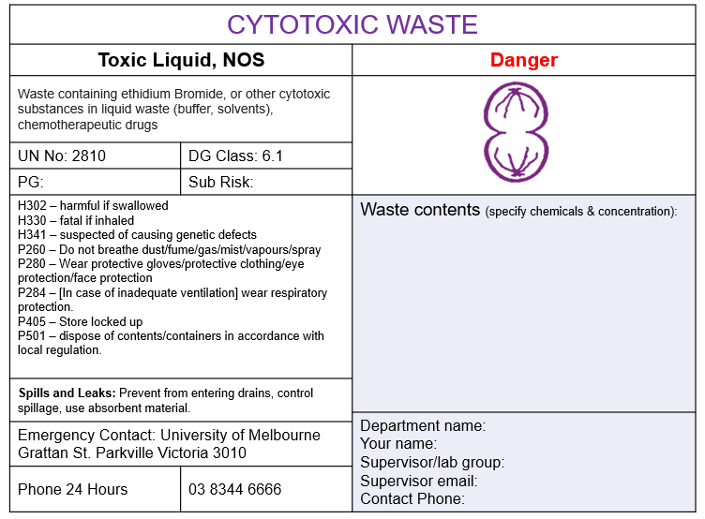 | Do not overfill container  The lid must be tightly secured  Do not place sharps directly into the pails. Sharps must be put in an approved sharp container before storing in the pail/bin.  Outcome: Incinerated
Oil waste | Oil may come from pumps, motors, vacuum driers. The oil is collected and blended for disposal and further recycling | Use 10L HDPE plastic carboy with approved lid; DG and UN approved; Must be compatible with the primary solvent | Affix this label on the carboy  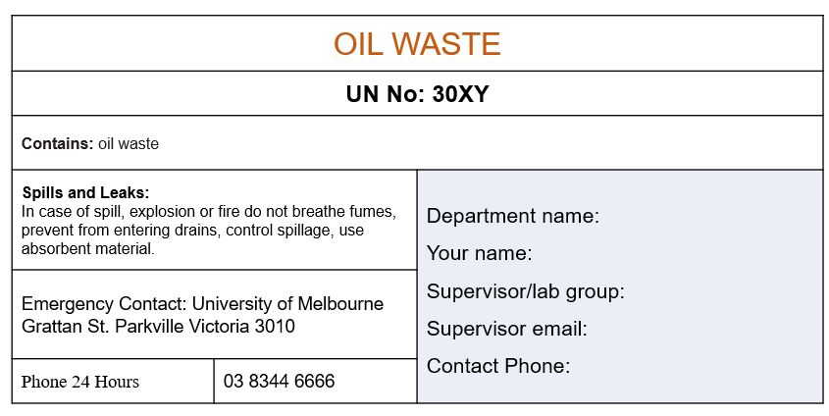 | Remove the ring of the lid before using the carboy.  The carboy should only be filled to the shoulder. The lid must be tightly sealed.  Check for leaks – if leaking, the contents must be decanted into a new carboy.  Carboy will be supplied by the waste contractor. Do not use Schott bottles or glass for any waste.  Outcome: Recycled

UNIVERSITY HAZARDOUS WASTE PICK UP (NO PURCHASE ORDER REQUIRED – COSTS COVERED BY HEALTH & SAFETY HAZARDOUS WASTE SERVICE AGREEMENT)
Cat 1 waste are waste products of laboratory activities from both research and teaching
Category | Definition | Container: Description, photo |  | Label | Further information
Solid contaminated waste | Any solid materials that have been contaminated with chemicals, e.g. paper towels and gloves used for cleaning up spills  Note:  Broken thermometers, any out-of-date solid chemicals (e.g. silica, pesticide solid) or bulk contaminated soil are not classified as solid contaminated waste. They are classified as  chemical waste (category 2) | Use white pails 20L with white lid  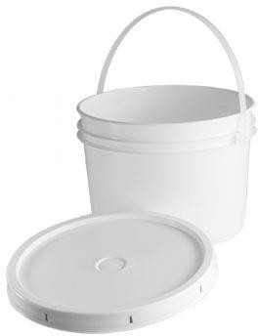 |  | Affix this label on the container and provide information on the chemical name/s  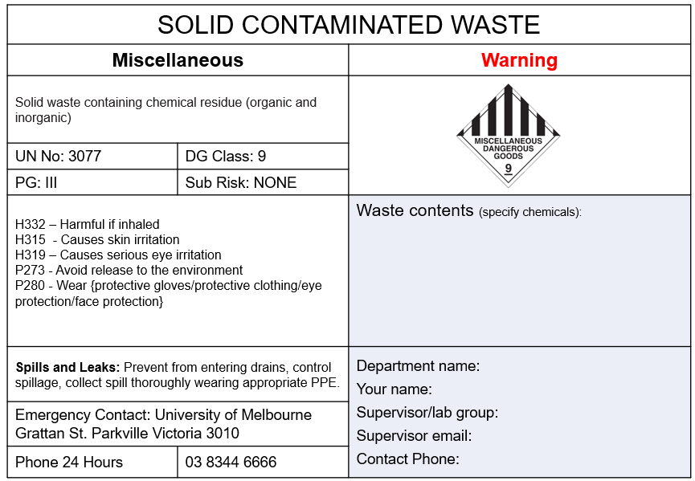 | The pail should be closed properly, and pails should not be overfilled.  Outcome: incinerated
Custom Waste Label | Custom waste label is used if:  - the waste does not fit into the above categories, or  - it has a specific composition, or  - if you’re unsure whether it will react to other waste. | Use 10L HDPE plastic with approved lid; DG and UN approved; Must be compatible with the primary solvent, or as specified in the Safety Data Sheet of the chemical. |  | Affix this label on the container and provide information on the chemical name/s, estimated concentration, pH and any hazard- and precaution-codes associated  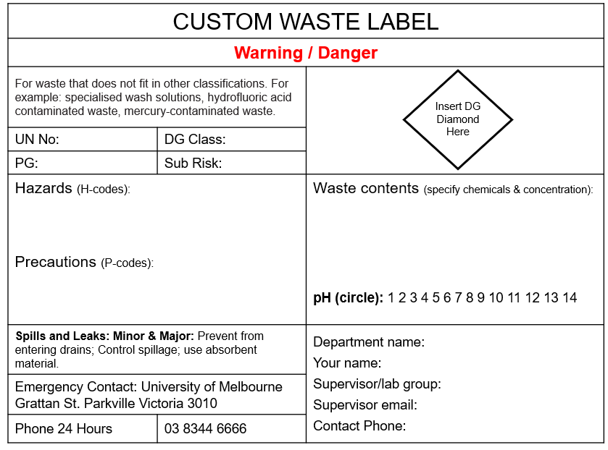 | Remove the ring of the lid before using the carboy.  The carboy should only be filled to the shoulder. The lid must be tightly sealed.  Check for leaks – if leaking, the contents must be decanted into a new carboy.  Carboy will be supplied by the waste contractor. Do not use Schott bottles or glass for any waste.  Outcome: Contractor will determine the best disposal path.
(Previously) radioactive material | Ionising radiation consists of highly energetic particles or electromagnetic waves that can detach electrons from atoms or molecules, thus ionising them. Ionising radiation is the spontaneous emission of energy in the form of particles or waves (electromagnetic radiation), or both | White 20L pail with white lid  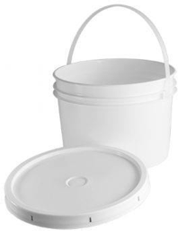 |  | Affix radiation trefoil label on container whilst decaying.  When no longer radioactive DEFACE OR REMOVE ALL RADIOACTIVE LABELS.  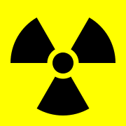    Replace with appropriate label. | Container type will depend on laboratory process. Waste is often contaminated PPE, 2.2ml Eppendorf tube, scintillation vial or original containers. Place gloves and preparatory material in a strong plastic lined white 20L pail.  A process of delay and decay to a level (where the waste is no longer classed as radioactive prior to disposal) is used.  See Ionising radiation management guidelines for managing radioactive waste  Note that there is NO waste stream for radioactive material  Contact your Departmental Radiation Safety Officer for further information.
Sharps non-biologically contaminated | Sharps that have been used for a purpose other than biological or clinical work.  Usually, they are chemically contaminated.  Sharps are defined as syringes, needles, lancets, scalpel blades and anything capable of cutting or penetrating the skin.  This includes glass slides, glass Pasteur pipettes, etc. | Use approved sharps container to AS4031 |  | N/A | Do not overfill container (check side view panel on container).  Lids must be secured properly.  Ensure that the rear drop counterbalance drawer (where fitted) can close and that the lid can be secured for relocation or locked for disposal  Outcome: Autoclaved, then deep burial
Sharps non-biologically contaminated |  | 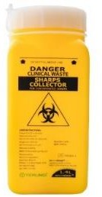 | Several full, fully locked sharp containers can be put in a 240 L bin as secondary container.  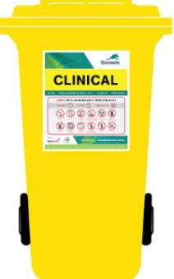 | N/A

UNIVERSITY HAZARDOUS WASTE PICK UP (PURCHASE ORDER NUMBER IS REQUIRED) - CAT 2 WASTE
Category | Definition | Container: Description, photo |  | Label | Further information
Sharps | Biologically contaminated sharps.  Sharps are defined as syringes, needles, lancets, scalpel blades and anything capable of cutting or penetrating the skin.  This includes glass slides, glass Pasteur pipettes, etc. | Use approved sharps container to AS4031 |  | Label is printed on appropriate waste container  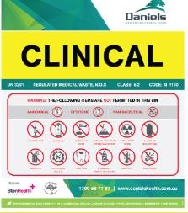 | Bench sharps container is transported in a closed secondary container (120L. 240L Wheelie bin)  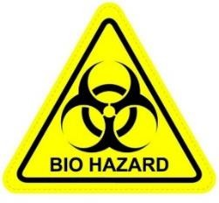  Treatment: Autoclaved, then deep burial
Sharps |  |  | Several full, fully locked sharp containers can be put in a 240 L bin as secondary container.
Clinical waste | Wastes arising from medical, dental, veterinary, laboratory, pharmaceutical, emergency services, blood banks, mortuary practices and other similar practices, such as wastes generated in other types of research facilities.  In general, this is waste that is contaminated with blood, microorganisms, viruses and other potential infectious substances. | Clinical waste bag. May be in Biohazard pail or open frame basket in the lab  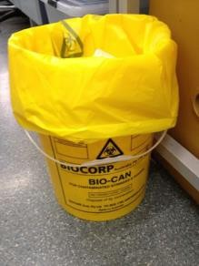 | Waste can also be placed directly in a lined 120L or 240L bin  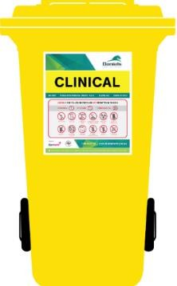 | Label is printed on appropriate waste container. | Do not overfill container or bag. Ensure that the bag can be secured using appropriate cable tie and the lid of the bin can be shut. Place in secondary container for transport  Treatment: Autoclaved, then deep burial
Anatomical waste | Waste from humans and animals  This will be waste that is recognisable body parts (not only human). | Yellow container with orange lid. Various bins (64L, 120L, 240L or 660L) are available.  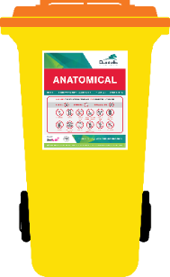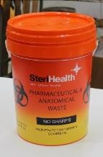 |  | Label is printed on appropriate waste container  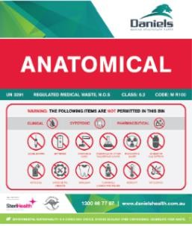 | The pails with lids are designed for non-sharps clinical waste only (the lids do not pass AS4031 which rates penetration)  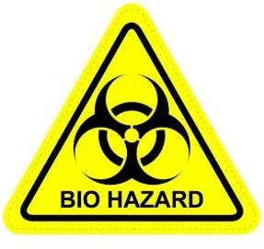  Treatment: Incinerated
Biosecurity (quarantine) waste | Any material determined by DAFF (Department of Agriculture, Fishery & Forestry) to be a biosecurity hazard. Normally a material that enters Australia from overseas and has risks to human health, animal health or the environment. | 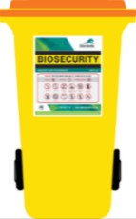  Various of Bio-Security bins (64L, 120L, 240L, 660L) are available. They are yellow bin with orange lid. It is labelled ‘BioSecurity’ and it is lockable. |  | Label is printed on appropriate waste container.  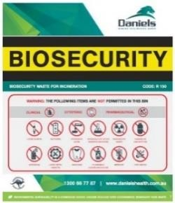 | Lockable Bio-Security waste bins are available from the hazardous waste contractor. These bins must be stored in secured area.  Treatment: Incinerated

UNIVERSITY HAZARDOUS WASTE PICK UP (PURCHASE ORDER NUMBER IS REQUIRED) – CAT 2 WASTE
Category | Definition | Container: Description, photo | Label | Further information
GMO waste | Any waste that contains potentially viable genetically modified organisms (GMOs) or genetically modified materials (GM materials). | Various types of GMO bins (240L, 660L) are available. They are yellow bins with a yellow lid. Bins are labelled ‘GMO’ and are lockable.  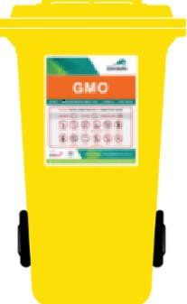 | Label is printed on appropriate waste container.  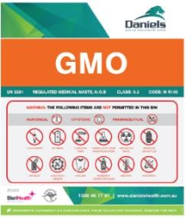 | Lockable GMO waste bins are available from the hazardous waste contractor. These bins must be stored in secured area.  Note:  Authorised disposal of GMOs must be adhered to the specific license’s conditions issued by the Gene Technology Regulator. This may include additional labelling, onsite treatment or disposal by an alternative method.  Treatment: Autoclave
Chemical disposal | Chemicals that have not been processed and are usually (but not always) in their original container.  Examples:  - excess chemicals that cannot be returned to supplier  - out-of-date chemicals | Use the original container that has its original label. | If label is not visible, stick a label with the name of the chemical.  Each chemical must be clearly identified. | It is essential that chemicals for disposal are clearly described on the manifest to ensure that appropriate transport containers are available. Liquids cannot be transported in pails.  Treatment: Dependent on waste type – normally incinerated

UNIVERSITY HAZARDOUS WASTE PICK UP (PURCHASE ORDER NUMBER IS REQUIRED) – CAT 2 WASTE
Category | Definition | Container: Description, photo | Label | Further information
Schedule poison – S2, 3, 4, 7 (listed regulated) | Items listed in Scheduled poison 2, 3, 4 and 7 (listed regulated) | Original container  Keep in a secured area until disposal. | N/A | Bring it to a pharmacy for disposal.  Weights and date of handover are recorded in the logbook.  For bulk disposal, contact the Chemical and Radiation Specialist.  Treatment: Incinerated
Schedule poison –  S4 (drugs of dependence), S8 and 9 | Items listed in Scheduled poison 4 (drugs of dependence), 8 and 9 | Original container | N/A | There is no contractor licensed to dispose of S8 and S9 products.  Options:  - Bring it to a pharmacy for disposal;  - The destruction is witnessed by two (2) approved medical practitioners, e.g. Vet.  Record the disposal path appropriately including the signature and name of the people who destroy the substance in the logbook.  To be consistent with the UoM procedure, S4 (drugs of dependence) is also disposed the same way with S8 and S9.  Treatment: Incinerated

