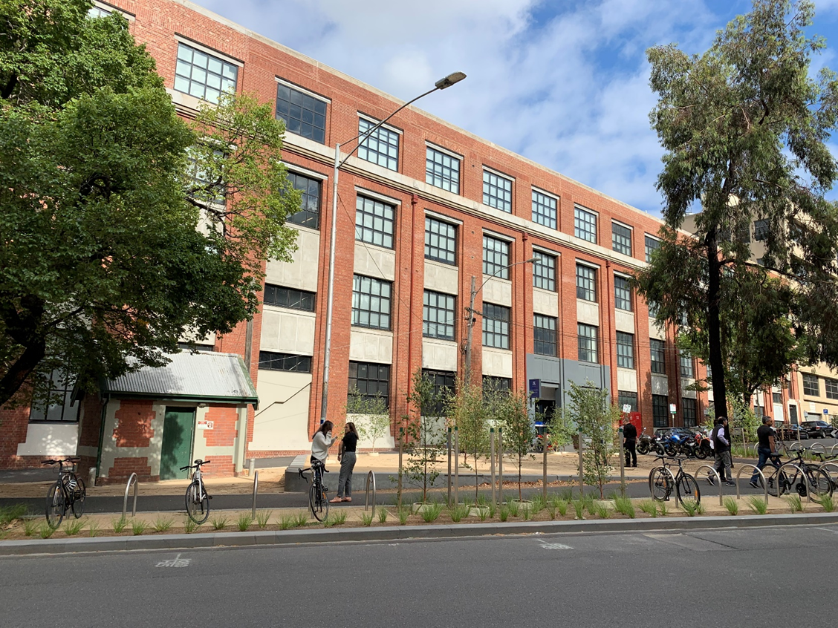

Emergency Management Plan
11 Barry Street, Carlton
Building No: 266

Site | Parkville
Building | 11 Barry Street, Carlton
Author | Ira Tedja
Plan Approver | Manager Health & Safety Specialist Services
Version | Draft 0.2
Date Approved
Next Review Date

Distribution list
Position Title | Name
Chief Warden
Emergency Management Contact | Susan Butler
Health & Safety Business Partner(s) | Manni Sidhu, Lisa Lovell, John Antunes & Janine Tickle
Plan Approver | Manager Health & Safety Specialist Services
Plan Reviewer | All of the above

Table of Contents
1. Purpose 1
2. Scope 1
3. Location occupancy and functions 1
3.1 Location and occupancy details 1
3.2 Site Infrastructure 2
3.3 Specialist area(s) 2
3.4 Dangerous Goods (DG) 2
3.5 Emergency Assistance 3
3.6 Neighbouring Properties/Buildings 3
4. Management Arrangements 3
4.1 Emergency Planning Committee (EPC) 3
4.2 Emergency Control Organisation (ECO) 3
5. EMERGENCY Resources 4
5.1 Emergency building infrastructure 4
5.2 Emergency equipment 5
5.3 Emergency personnel 5
5.4 Personal emergency evacuation plan (PEEP) 5
5.5 Training 5
5.6 Posters, diagrams and checklist 6
5.7 Other Resources 6
6. EMERGENCY procedures 6
6.1 Emergency codes 6
6.2 Escalation process 6
6.3 After hours procedure 7
7. Associated Documents and references 7
7.1 Templates and forms 7
7.2 Guidance 7
7.3 Processes and requirements 7
7.4 References 7

Purpose
Health & Safety – Emergency Preparedness and Response Requirement
The purpose of this Emergency Management Plan (EMP) is to provide 11 Barry Street, Carlton with a framework that outlines the resources and processes required to effectively respond to emergencies.

Scope
This plan includes the structure and duties of the Emergency Planning Committee (EPC) and Emergency Control Organisation (ECO). The plan also contains an emergency plan specific for 11 Barry Street, Carlton including the emergency resources, equipment, any emergency related training and Personal Emergency Evacuation Plan (PEEP).

Location occupancy and functions

Location and occupancy details

Building layout/characteristics | 11 Barry Street is a heritage red brick building consisting of four levels and a roof space.
Location and surrounding buildings/structures etc | The building is located on the corner of Barry Street and Queensberry Street, with Berkley Street to the rear of the building.
Access/egress | Evacuation stairs are located:  - Barry Street north end  - Barry Street south end  Berkeley Street north end
Assembly point/s | University Square
Work area(s) description | This building is an office-based activity building.  Levels one, two and three are used as open plan office areas.  A data centre is located on the ground level.  The roof space is only accessible by Campus Services and contractors.
Delivery points | Reception is located on level 1 and attended by a receptionist. All mails and deliveries are sent to this point.
Occupancy details (general) | The majority of building occupants are office workers employed directly by the university. There are also some contract office employees and a small number of visitors. There are approximately 360 people occupying this building.
Occupancy details (specialist) | Maintenance contractors and cleaning contractors also access the building.

Site Infrastructure
 | Type | Y/N | Remarks
Utilities | Gas/propane | N | Shut-off location:
 | Water | Y | Shut-off location: Corner Queensberry St and Barry St
 | Electricity | Y | Shut-off location: See Figure 1
 | Solar panel | N | Shut-off location:
Emergency Power System |  |  | Provides power to:
 |  |  | Shut-off location:
Boiler Room
Substation |  | Y | See Figure 1
Other Services |  | N

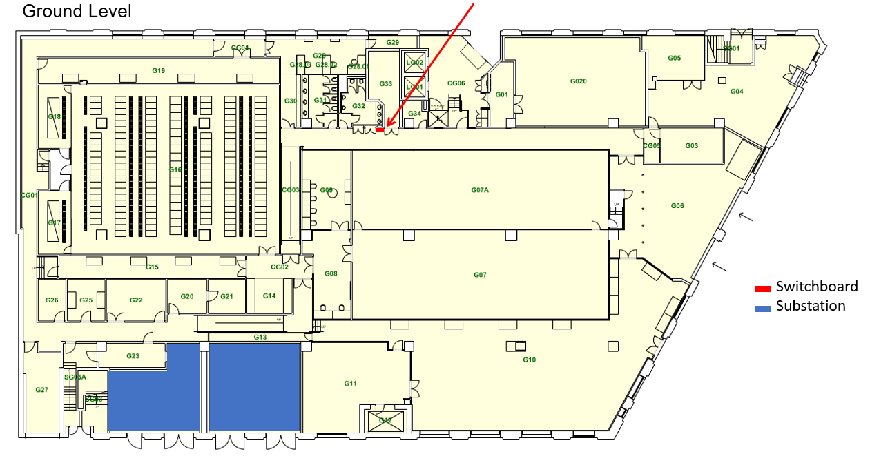
Figure 1. Electrical Switchboard and Substation Location

Specialist area(s)
Description | Location
Data centre unit | Ground floor, roof
3 x Uninterruptable Power Supplies | Ground floor

Dangerous Goods (DG)
Placard(s) | Location of Emergency Information Book
DG 2.2 and C1 | Entrance, ground floor

Emergency Assistance
Parkville Campus Security | 03 8344 6666
Emergency services | 0 000
Poison Information Centre | 13 11 26

Neighbouring Properties/Buildings
11 Barry Street is surrounded by student accommodation apartments, offices, convenience stores, cafes and the Melbourne Graduate School of Education building. Next door building (45 Barry St), is owned and occupied by Telstra, some spaces are tenanted to UoM. Their activities are low risk activities.
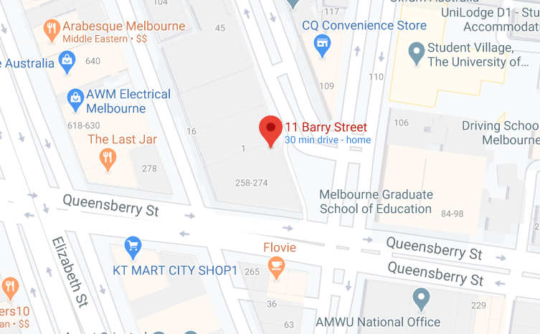
Figure 2 Neighbouring Properties

Management Arrangements
As stipulated by the Health & Safety – Emergency preparedness and response requirements, a building may require having an Emergency Planning Committee (EPC). When a building does not have an EPC, the Emergency Control Organisation (ECO) will assume the responsibilities of the EPC of that building.

Emergency Planning Committee (EPC)
This building does not have an EPC. Duties of the EPC are undertaken by the ECO.

Emergency Control Organisation (ECO)
The ECO is led by the Chief Warden. The Chief Warden, assisted by the respective Health and Safety Business Partner, is responsible for the development and maintaining the currency of the:
- EMP of the building including the sufficiency of emergency personnel for the building.
- Evacuation procedure for the building.
- Personal Emergency Evacuation Procedure (PEEP) to accommodate disabled persons if they are in the building.
The ECO consists of:
- Chief Warden
- Deputy Chief Warden(s)
- Floor Warden
- First aider
- Health and safety Business Partner
The Chief Warden role is responsible for managing the emergency procedure for this building.
In an event of emergency:
- Take leadership in managing the emergency evacuation process including delegating tasks
- Liaising with Campus Security and Emergency Services
After an emergency:
- Complete the Building Evacuation Checklist and submit to emergency-management@unimelb.edu.au
Non-emergency function:
- Plan a yearly evacuation drill for the building
- Organise a yearly EPC meeting and ensure the EMP is current

EMERGENCY Resources

Emergency building infrastructure
Building emergency fittings visual guide
Building infrastructure | Y/NA | Remark
Duress Alarm | Y | Location: Adjacent to the service desk on Level 1
Emergency Break Glass Alarm | Y | Ground floor main entrance and fire escape exits on each level.
Emergency Warning Intercommunication System (EWIS) | Y | Two tone evacuation system with voice evacuation notification – “Evacuate now”
Warden Intercom Phones (WIP) | N
Exit Break Glass Door Release | Y | At all fire escape exit doors leading to the outside the building
Fire Indicator Panel | Y | Ground floor main entrance
Smoke and Thermal Fire Detectors | Y | Maintained and tested by campus Services
Sprinkler and Suppression System | Y | Maintained and tested by campus Services

Emergency equipment
Building emergency fittings visual guide
Fire extinguisher types and their uses
Emergency equipment is included in the Evacuation Diagrams displayed across the building
Equipment | Y/NA | Remark
Automated External Defibrillator (AED) | Y | Location: At the reception desk on level 1
Fire Blankets | Y | Located in kitchens and kitchenettes
Fire Extinguishers | Y | Located throughout building and indicated on evacuation diagrams
First Aid Kits | Y | At least one per level as determined by first aid risk assessment

Emergency personnel
Emergency personnel posters are displayed across the building, including at exit points.
Description | Remark
Building Chief Warden and Deputy Chief Warden | One Chief Warden and One Deputy Chief Warden
Floor Wardens | Wardens are assigned for each level ground and 1 to 3 (each wing – north and south).
First Aiders | First aid assessment form  As determined by first aid risk assessment for this building, including the number of first aiders (at least two per floor) and training requirements – Provide First Aid (Level 2) - HLTAID003.

Personal emergency evacuation plan (PEEP)
Personal emergency evacuation plan
Currently no one requires PEEP. In the future, if required, a PEEP will be included in this plan and made available to relevant personnel, including members of the ECO and line manager.

Training
Personnel | Training required | Resources
Visitor | None | Visitor Emergency Guide
Employees, contractors, relevant students | Health and Safety – Roles and Responsibilities | TrainME
 | Local Induction | Direct Supervisor
 | Participate in yearly evacuation drill | Chief Warden
Front liners, e.g. Reception, library employees, Health Services, Stop One | Suspicious Package training | Enrol in TrainME
 | Aggressive behaviours/customers | Local area responsibility
 | Warden training and refresher every 3 years | TrainME
Chief Warden, Deputy Chief Warden, Warden | Conduct yearly evacuation drill
 | Fire extinguisher training (elective) | Enrol in TrainME
 | Suspicious Packages training (elective) | Enrol in TrainME
First Aiders | Provide First Aid (Level 2) - HLTAID003 | Enrol in TrainME
 | Provide Cardiopulmonary Resuscitation (CPR) – HLTAID001 | Enrol in TrainME

Posters, diagrams and checklist
The Emergency Response Procedure (Flipchart) is installed across key locations near Evacuation diagrams, Emergency contacts posters and common areas. Members of the ECO are provided with a copy of the flipchart. Forms and Checklists are available on the Emergency Preparedness and Response

Other Resources
The University Counselling Service and the Employee Assistance Program are available to assist employees who have experienced psychological trauma.

EMERGENCY procedures

Emergency codes
The University of Melbourne has considered the emergency code system outlined in AS 3745. Detailed information on these emergency codes is available on Flipcharts available widely across the University.
Colour | Emergency | Note
Orange | Evacuation | Two tone evacuation system with voice evacuation notification – “Evacuate now”
Red | Fire/smoke
Purple | Bomb thread | Bomb/substance and phone threat checklist
Blue | Medical emergency
Black | Personal threat | Duress alarms at reception
Yellow | Internal emergency
Brown | External emergency

Escalation process
When an emergency cannot be managed by the Chief Warden, the incident may be escalated to the University of Melbourne Incident Management System (UMIMS). Contact University of Melbourne Security for assistance on 8344 6666.

After hours procedure
When an emergency occurs after hours, a person must contact Security directly and follow any instructions from Security.

Associated Documents and references

Templates and forms
Bomb/substance and phone threat checklist
Building emergency procedures poster
Building evacuation checklist
Emergency contacts poster
First aid assessment form
Personal emergency evacuation plan

Guidance
Emergency Response Procedure (Flipchart)
Building emergency fittings visual guide
Fire extinguisher types and their uses
First aid assessment samples

Requirements
Health & Safety – Emergency Preparedness and Response Requirement
References
Occupational Health and Safety Act 2004
AS 3745 – 2010: Planning for emergencies in facilities
Compliance Code: First aid in the workplace (Vic)

